# Machine Deployement

## DS2 Deployment

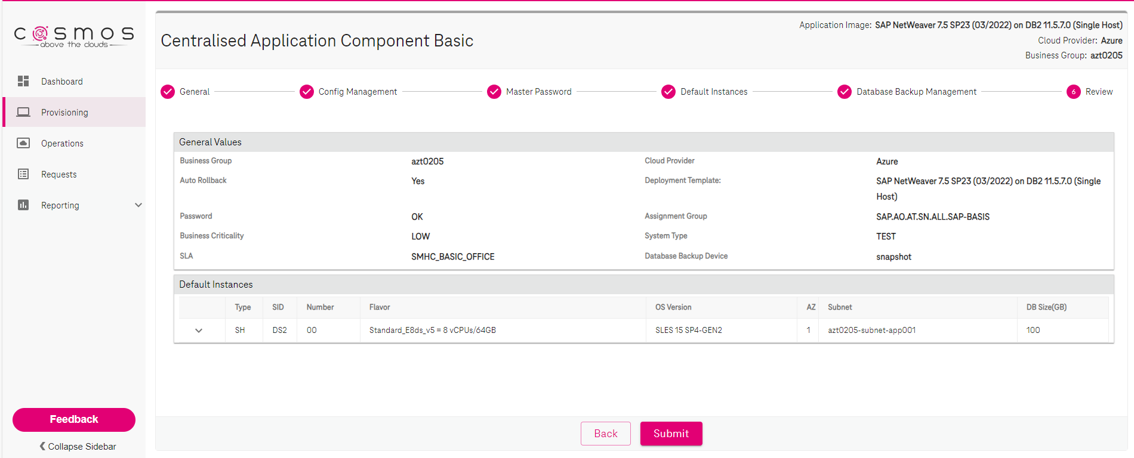

## DS3 Deployment

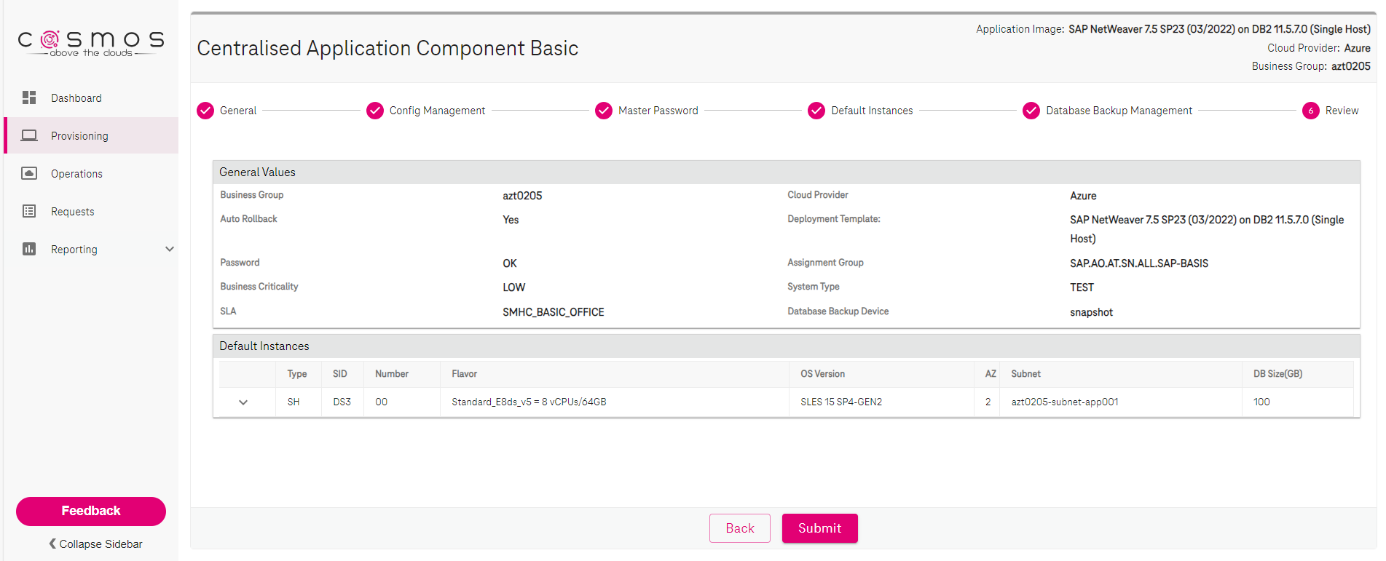

## Backup Enabled on source(DS2) and target(DS3)





# Changes Made on DS2 Machine

aztshds20001:db2ds2 6> db2 list tables for all | grep -i increment

aztshds20001:db2ds2 7> db2pd -d ds2 -tablespace | grep -i increment

## aztshds20001:db2ds2 9> db2 -stvf increment.sql -z increment.out

CREATE DATABASE PARTITION GROUP "SAP_INCREMENT" ON DBPARTITIONNUMS (0)

DB20000I The SQL command completed successfully.

CREATE LARGE TABLESPACE "INCREMENTAL CHECKS" IN DATABASE PARTITION GROUP SAP_INCREMENT PAGESIZE 16384 MANAGED BY AUTOMATIC STORAGE USING STOGROUP "IBMSTOGROUP" AUTORESIZE YES INITIALSIZE 32 M MAXSIZE NONE EXTENTSIZE 2 PREFETCHSIZE AUTOMATIC BUFFERPOOL "IBMDEFAULTBP" DATA TAG INHERIT OVERHEAD INHERIT TRANSFERRATE INHERIT DROPPED TABLE RECOVERY OFF

DB20000I The SQL command completed successfully.

CREATE LARGE TABLESPACE "EXTRA_INCREMENT" IN DATABASE PARTITION GROUP SAP_INCREMENT PAGESIZE 16384 MANAGED BY AUTOMATIC STORAGE USING STOGROUP "IBMSTOGROUP" AUTORESIZE YES INITIALSIZE 32 M MAXSIZE NONE EXTENTSIZE 2 PREFETCHSIZE AUTOMATIC BUFFERPOOL "IBMDEFAULTBP" DATA TAG INHERIT OVERHEAD INHERIT TRANSFERRATE INHERIT DROPPED TABLE RECOVERY OFF

DB20000I The SQL command completed successfully.

CREATE SCHEMA "INCREMENTAL" AUTHORIZATION "SAPAZ9 "

DB20000I The SQL command completed successfully.

CREATE TABLE "INCREMENTAL "."INCREMENT" ( "VERSION" VARCHAR(216 OCTETS) NOT NULL WITH DEFAULT ' ' ) COMPRESS YES ADAPTIVE IN "INCREMENTAL CHECKS" INDEX IN "INCREMENTAL CHECKS" ORGANIZE BY ROW

DB20000I The SQL command completed successfully.

SET SYSIBM.NLS_STRING_UNITS = 'SYSTEM'

DB20000I The SQL command completed successfully.

CREATE UNIQUE INDEX "INCREMENTAL "."INCREMENT~0" ON "INCREMENTAL "."INCREMENT" ("VERSION" ASC) PCTFREE 0 COMPRESS YES INCLUDE NULL KEYS ALLOW REVERSE SCANS

DB20000I The SQL command completed successfully.

## aztshds20001:db2ds2 12> db2pd -d ds2 -tablespaces | grep -i increment

0x00007FD6D0EB81A0 1 DMS Large 16384 2 Yes 2 1 1 Def 1 0 511 Yes INCREMENTAL CHECKS

0x00007FD6D0ECF760 2 DMS Large 16384 2 Yes 2 1 1 Def 1 0 511 Yes EXTRA_INCREMENT

## aztshds20001:db2ds2 13> db2 list tables for all | grep -i increment

INCREMENT INCREMENTAL T 2023-09-20-08.17.15.101283

aztshds20001:db2ds2 14>

aztshds20001:db2ds2 15> db2 terminate

DB20000I The TERMINATE command completed successfully.

aztshds20001:db2ds2 16> db2 archive log for db ds2

DB20000I The ARCHIVE LOG command completed successfully.

aztshds20001:db2ds2 17> db2 archive log for db ds2

DB20000I The ARCHIVE LOG command completed successfully.

aztshds20001:db2ds2 17> db2 archive log for db ds2

DB20000I The ARCHIVE LOG command completed successfully.

aztshds20001:db2ds2 17>

# Take Backup on source (DS2):

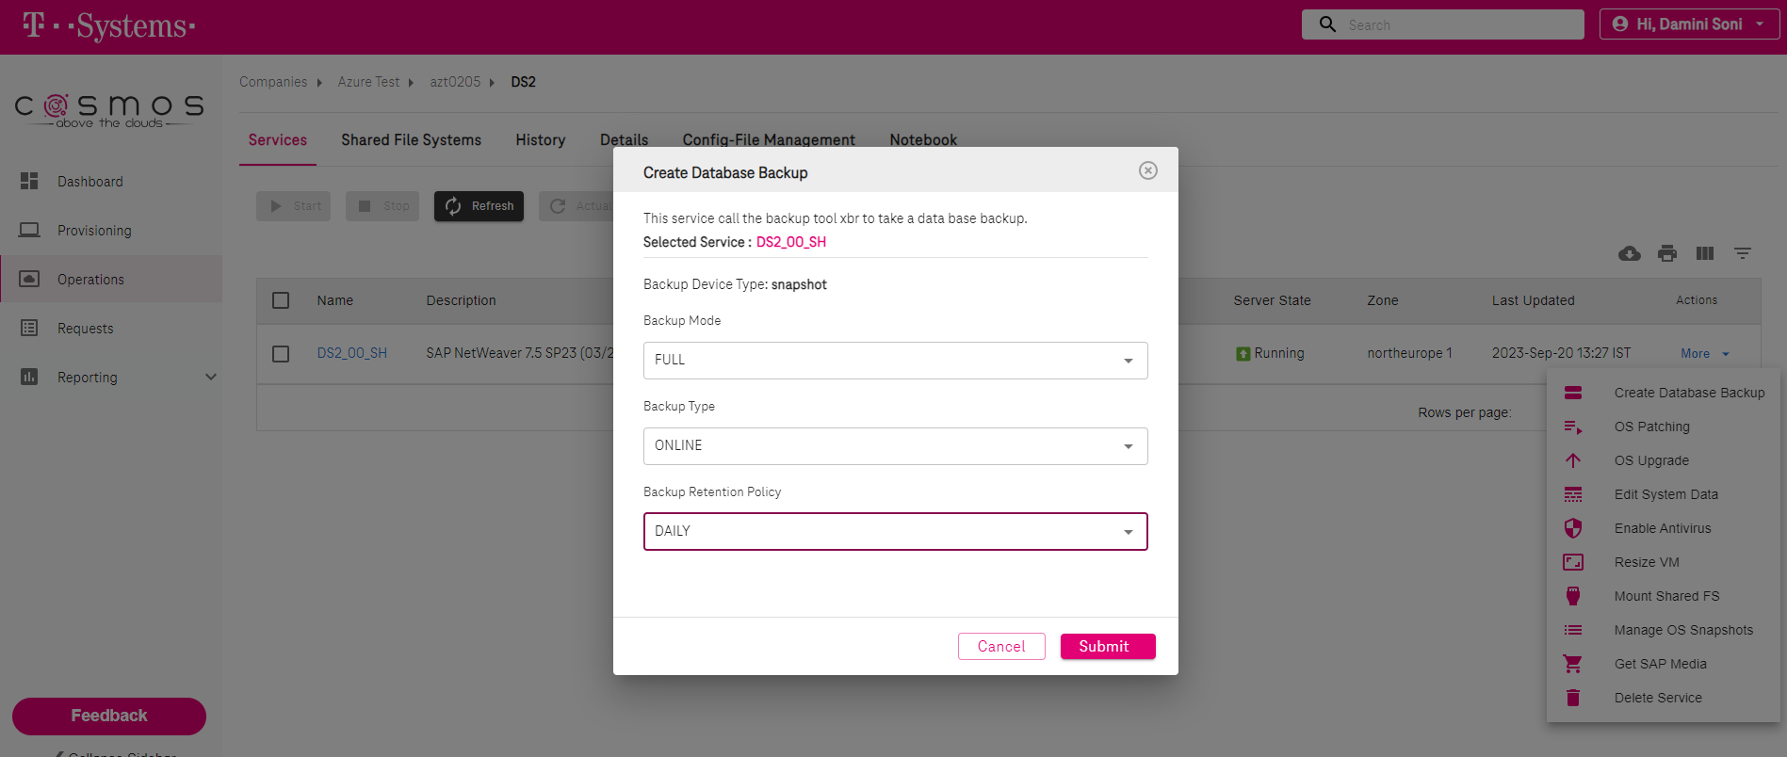



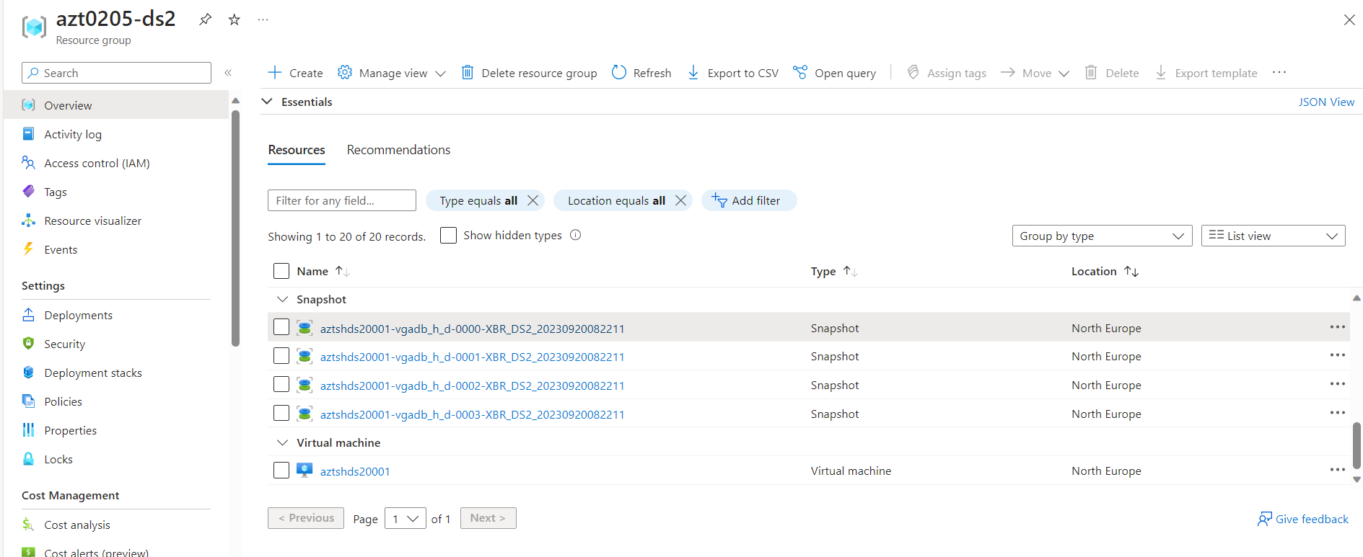

# Either Copy snapshot of data fs snapshots taken into single backup run on target (DS3) or Create Disk directly from source snapshot into Target resource group and attach those disk from portal after detaching previous ones’s.

Here we are creating snapshot and then will follow restore steps..

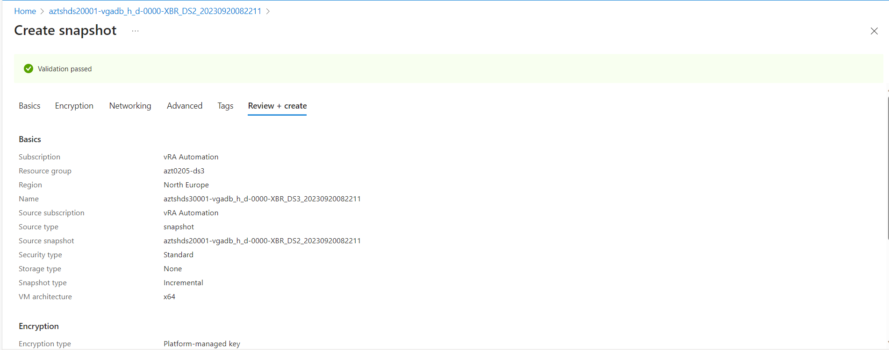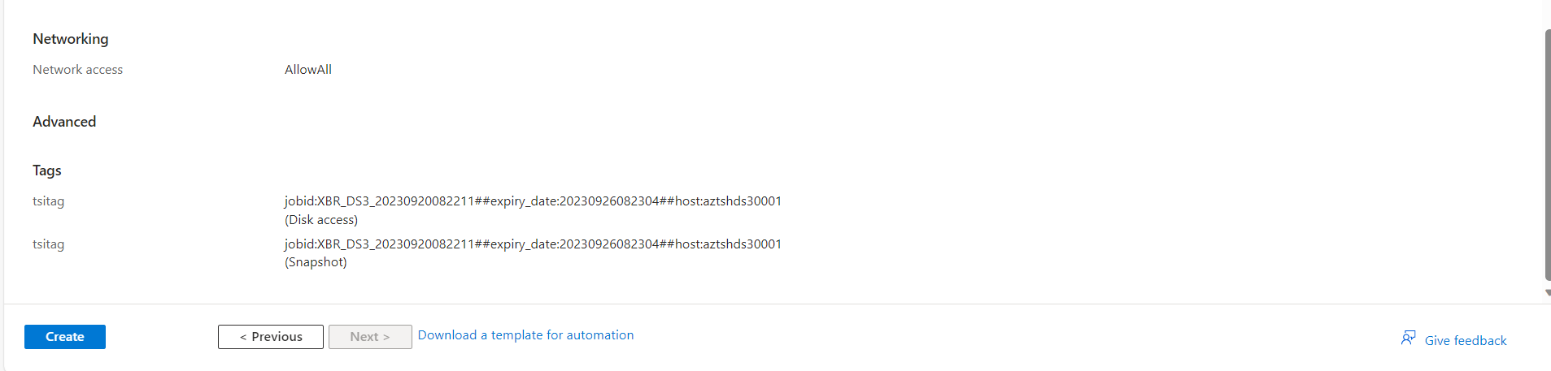

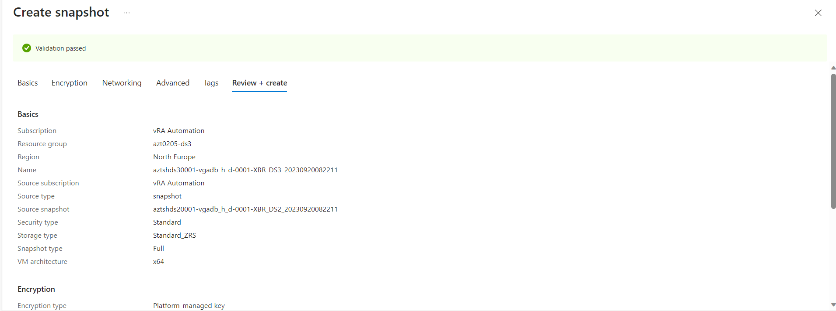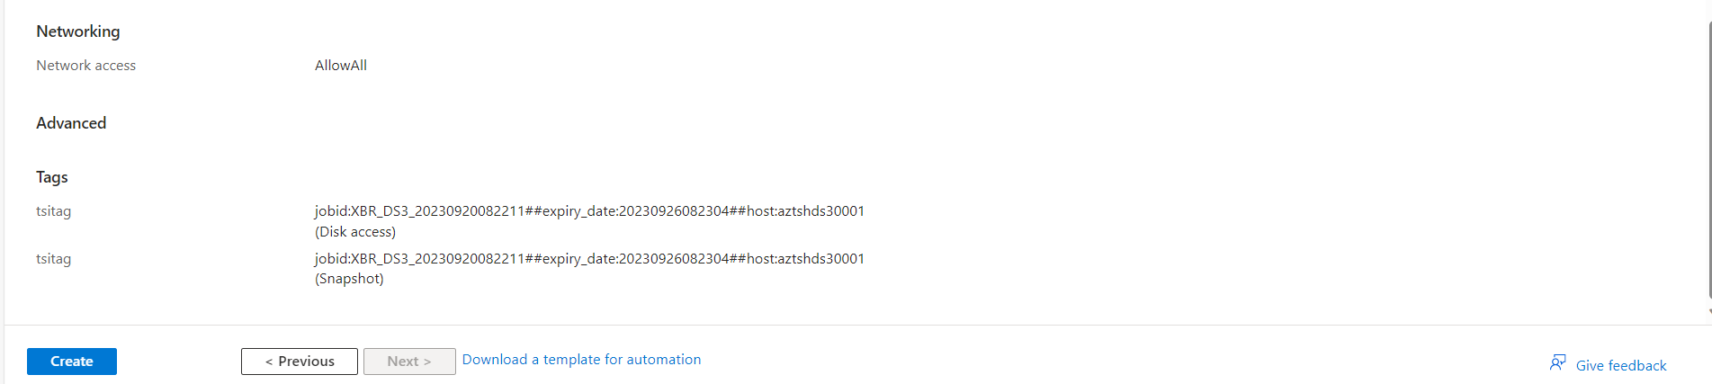

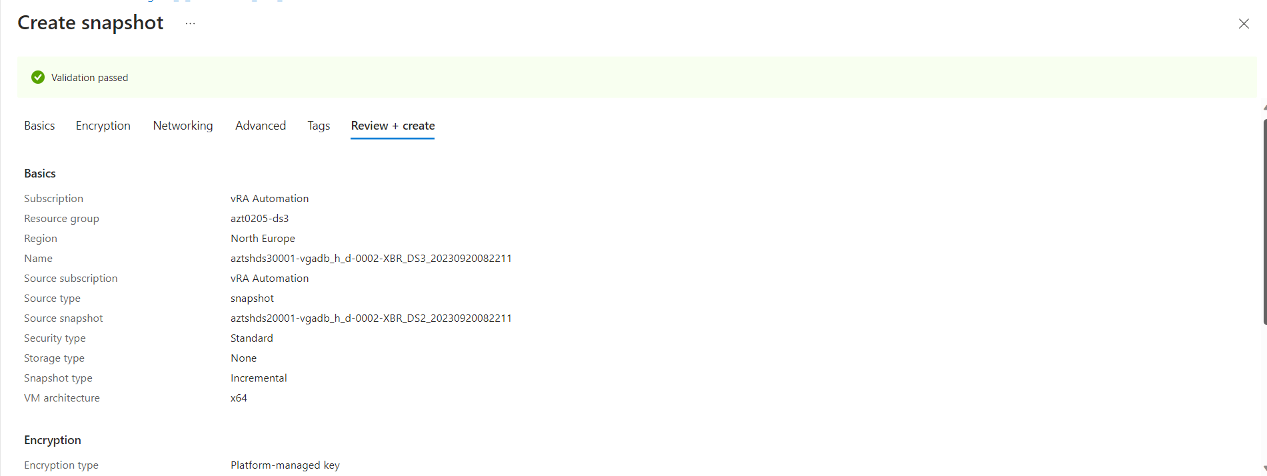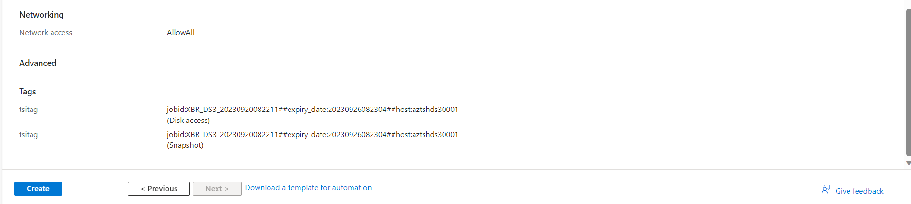

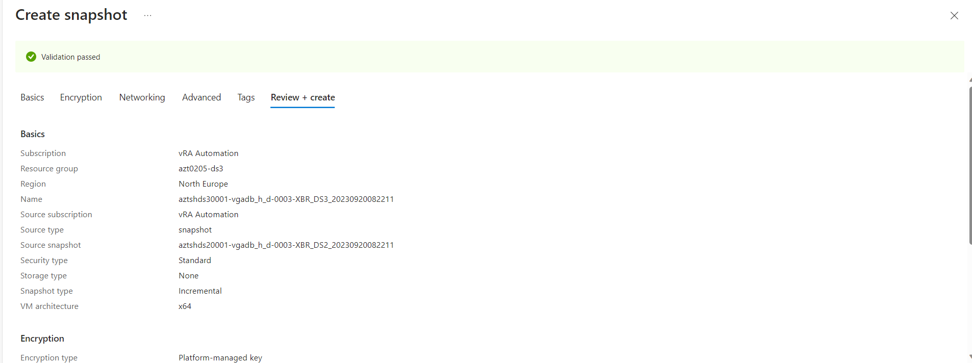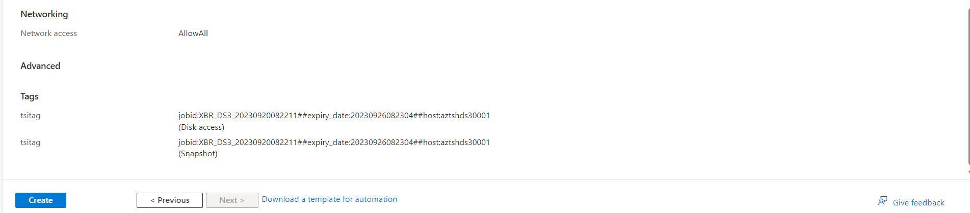

## aztshds30001:ds3adm 4> sudo /usr/local/platform/bin/iaas.py --cfg ~/DS3 --mode application --action list_snapshot

2023-09-20 09:01:39,729 - INFO - Authenticate against the Azure API with the stored certificate.

2023-09-20 09:01:40,577 - INFO - Iaas Tool Storage Provider Version (AzureDisk): 1.2.9

2023-09-20 09:01:41,406 - INFO - Snapshots

2023-09-20 09:01:41,406 - INFO - ... Snapshot-Name: aztshds30001-vgadb_h_d-0000-XBR_DS3_20230920082211

2023-09-20 09:01:41,406 - INFO - ... Creation-date: 20230920084508

2023-09-20 09:01:41,406 - INFO - ... Expiration-date: 20230926082304

2023-09-20 09:01:41,406 - INFO - ... Location: northeurope

2023-09-20 09:01:41,406 - INFO - ... Job-ID: XBR_DS3_20230920082211

2023-09-20 09:01:41,406 - INFO - ... Source-host: aztshds30001

2023-09-20 09:01:41,406 - INFO - ... Snapshot-Name: aztshds30001-vgadb_h_d-0001-XBR_DS3_20230920082211

2023-09-20 09:01:41,406 - INFO - ... Creation-date: 20230920085126

2023-09-20 09:01:41,407 - INFO - ... Expiration-date: 20230926082304

2023-09-20 09:01:41,407 - INFO - ... Location: northeurope

2023-09-20 09:01:41,407 - INFO - ... Job-ID: XBR_DS3_20230920082211

2023-09-20 09:01:41,407 - INFO - ... Source-host: aztshds30001

2023-09-20 09:01:41,407 - INFO - ... Snapshot-Name: aztshds30001-vgadb_h_d-0002-XBR_DS3_20230920082211

2023-09-20 09:01:41,407 - INFO - ... Creation-date: 20230920085636

2023-09-20 09:01:41,407 - INFO - ... Expiration-date: 20230926082304

2023-09-20 09:01:41,407 - INFO - ... Location: northeurope

2023-09-20 09:01:41,407 - INFO - ... Job-ID: XBR_DS3_20230920082211

2023-09-20 09:01:41,407 - INFO - ... Source-host: aztshds30001

2023-09-20 09:01:41,407 - INFO - ... Snapshot-Name: aztshds30001-vgadb_h_d-0003-XBR_DS3_20230920082211

2023-09-20 09:01:41,407 - INFO - ... Creation-date: 20230920090035

2023-09-20 09:01:41,407 - INFO - ... Expiration-date: 20230926082304

2023-09-20 09:01:41,407 - INFO - ... Location: northeurope

2023-09-20 09:01:41,408 - INFO - ... Job-ID: XBR_DS3_20230920082211

2023-09-20 09:01:41,408 - INFO - ... Source-host: aztshds30001

aztshds30001:ds3adm 4>

aztshds20001:~ # chmod 777 /tmp/DB_restore/

aztshds30001:~ # chown -R db2ds3:sapsys /tmp/DB_restore/

aztshds20001:~ # su - ds2adm

aztshds20001:ds2adm 16> cd xbrTools/

## aztshds20001:ds2adm 17> ./xbrbackup -restore -restore_date_from=20230920082211 -restore_date_to=20230920083017 -restore_to_dir=/tmp/DB_restore -restore_orig_dir=/db2/DS2/sapbackup -restore_to_sid=DS3

Xbr*Tools Wrapper v1.4

Starting /usr/sap/DS2/home/xbrTools/xbrTools/xbrbackup.csh

XBR0001I XBR*Backup Version 1.47.0005 T-Systems International GmbH

XBR0005I XBR*Backup log file: '/db2/DS2/sapbackup/gfarsibr.rsb'

XBR0500I Start of data restore for database instance: 'DS2' 2023-09-20 09.15.07

XBR0010I Parameters (Profiles):

Name Value

----------------------------------- --------------------------------------------------------------------------------------------------------------------------------------------------------------------------------

archive_copy_dir az://azt0205/archivepool/aztshds20001

archive_dir /db2/DS2/log_archive

archive_max_loop_count 20

az_max_connections 0

backup_cons_timeout 600

backup_dev_type snapshot

backup_log_dir /db2/DS2/sapbackup

backup_longretention_dir az://azt0205/backup/aztshds20001/xbrlong

backup_root_dir az://azt0205/backup/aztshds20001

backup_type online

cleanup_backup_catalog yes

cleanup_disk_archive 37

cleanup_disk_backup 37

cleanup_disk_backup_weekly 37

cleanup_log 60

cmd_line xbrbackup.pl -restore -restore_date_from=20230920082211 -restore_date_to=20230920083017 -restore_to_dir=/tmp/DB_restore -restore_orig_dir=/db2/DS2/sapbackup -restore_to_sid=DS3

compress yes

compress_cmd pigz -5

compress_verify yes

compress_verify_backup no

compress_verify_cmd pigz -t

db2_compress yes

db2_databases DS2

db2_logarchmeth 1, 2

dbsid DS2

dbtype DB2

disk_backup_parallel 8

exec_parallel 1

history_table SAPTOOLS.XBRHIST

init_files /usr/sap/DS2/home/xbrTools/xbrTools_1.47.0005/init.xbr, /usr/sap/DS2/home/xbrTools/initDS2.xbr

keep_archive_count 0

local_backup_dir /db2/DS2/localbackup

log_dir /db2/DS2/sapbackup

logswitch_interval 3300

mode full

perl_interpreter /usr/bin/perl

perl_version v5.26.1

process_info 10896 db2ds2(32000)/db2ds2(32000) sapsys(200)/sapsys(200)

restore 1

restore_date_from 20230920082211

restore_date_to 20230920083017

restore_orig_dir /db2/DS2/sapbackup

restore_to_dir /tmp/DB_restore

restore_to_sid DS3

retention_policy daily

snapshot_interface publiccloud

snapshot_retention_primary 6

snapshot_retention_primary_weekly 37

snapshot_retention_secondary 3

snapshot_retention_secondary_weekly 3

snapshot_svunsched yes

snapshot_timeout 1200

snapshot_transfer_daily no

snapshot_transfer_project no

snapshot_transfer_timeout 46800

snapshot_verify no

snapshot_waittime 900

system_info Linux aztshds20001 5.14.21-150400.24.28-default #1 SMP

temp_dir /var/tmp

time_zone UTC +0000

uncompress_cmd pigz -d

userid_info uid=32000(db2ds2) gid=200(sapsys) groups=200(sapsys),400(sapinst),31000(dbds2adm),32000(dbds2ctl)

XBR0034I Registered OS-Commands:

Command Path

------------------------------ -----------------------------------------

az /usr/bin/az

azcopy /usr/bin/azcopy

date /usr/bin/date

db2 /home/db2ds2/sqllib/bin/db2

db2cfexp /home/db2ds2/sqllib/bin/db2cfexp

db2dart /home/db2ds2/sqllib/adm/db2dart

db2start /home/db2ds2/sqllib/adm/db2start

db2stop /home/db2ds2/sqllib/adm/db2stop

dd /usr/bin/dd

getent /usr/bin/getent

hostname /usr/bin/hostname

id /usr/bin/id

pigz /usr/bin/pigz

tar /usr/bin/tar

uname /usr/bin/uname

XBR0410I Restore function: restore_backupfiles

saved_from_dir: /db2/DS2/sapbackup/

restore_to_dir: /tmp/DB_restore/

dst_path: /tmp/DB_restore/DS2_db2_home.tar.Z

saved_from_dir: /db2/DS2/sapbackup/

restore_to_dir: /tmp/DB_restore/

dst_path: /usr/sap/DS2/home/xbrTools/xbrTools_1.47.0005/init.xbr

XBR0430I File '/usr/sap/DS2/home/xbrTools/xbrTools_1.47.0005/init.xbr' (2022-09-07 14.31.55) exists, will be skipped from restore

saved_from_dir: /db2/DS2/sapbackup/

restore_to_dir: /tmp/DB_restore/

dst_path: /tmp/DB_restore/xbrbackDS2.log

saved_from_dir: /db2/DS2/sapbackup/

restore_to_dir: /tmp/DB_restore/

dst_path: /usr/sap/DS2/home/xbrTools/initDS2.xbr

saved_from_dir: /db2/DS2/sapbackup/

restore_to_dir: /tmp/DB_restore/

dst_path: /tmp/DB_restore/gfarrssd.anf

saved_from_dir: /db2/DS2/sapbackup/

restore_to_dir: /tmp/DB_restore/

dst_path: /tmp/DB_restore/DBM.cfg

saved_from_dir: /db2/DS2/sapbackup/

restore_to_dir: /tmp/DB_restore/

dst_path: /tmp/DB_restore/xbrbackstatDS2.log

/usr/sap/DS2/home/xbrTools/initDS3.xbr 2023-09-20 07.53.12 253

/tmp/DB_restore/xbrbackstatDS3.log 2023-09-20 07.55.56 0

/tmp/DB_restore/xbrbackDS3.log 2023-09-20 08.22.13 174

/tmp/DB_restore/DBM.cfg 2023-09-20 08.22.40 2726

/tmp/DB_restore/DS3_db2_home.tar.Z 2023-09-20 08.23.53 102516

/tmp/DB_restore/gfarrssd.anf 2023-09-20 08.30.15 62369

XBR0414I 6 files found for restore, total size 0.160 MB 2023-09-20 09.15.12

XBR0144I Restoring '/usr/sap/DS2/home/xbrTools/initDS3.xbr'

XBR0145I from 'az://azt0205/backup/aztshds20001/xbrback/20230920082211/initDS2.xbr'... 2023-09-20 09.15.16

XBR0144I Restoring '/tmp/DB_restore/xbrbackstatDS3.log'

XBR0145I from 'az://azt0205/backup/aztshds20001/xbrback/20230920082211/xbrbackstatDS2.log'... 2023-09-20 09.15.16

XBR0144I Restoring '/tmp/DB_restore/xbrbackDS3.log'

XBR0145I from 'az://azt0205/backup/aztshds20001/xbrback/20230920082211/xbrbackDS2.log'... 2023-09-20 09.15.16

XBR0144I Restoring '/tmp/DB_restore/DBM.cfg'

XBR0145I from 'az://azt0205/backup/aztshds20001/xbrback/20230920082211/DBM.cfg'... 2023-09-20 09.15.16

XBR0109I Decompressing '/tmp/DB_restore/DS3_db2_home.tar.Z'

XBR0110I from 'az://azt0205/backup/aztshds20001/xbrback/20230920082211/DS2_db2_home.tar.Z'... 2023-09-20 09.15.16

XBR0144I Restoring '/tmp/DB_restore/gfarrssd.anf'

XBR0145I from 'az://azt0205/backup/aztshds20001/xbrback/20230920082211/gfarrssd.anf'... 2023-09-20 09.15.16

Redundant argument in sprintf at lib/LogPrinter.pm line 202.

XBR0104E Copying file from 'az://azt0205/backup/aztshds20001/xbrback/20230920082211/initDS2.xbr' to '/usr/sap/DS2/home/xbrTools/initDS3.xbr' failed: 1

XBR0016W File '/usr/sap/DS2/home/xbrTools/initDS3.xbr' does not exist!

XBR0420E 0 backup files in 5 seconds processed: Compression 0B->0B ratio 0.000% 2023-09-20 09.15.17

XBR0998E XBR*Backup completed with errors at 2023-09-20 09.15.17, return code 5

## aztshds20001:ds2adm 18> ls -ltr /tmp/DB_restore/

total 38152

-rw-r--r-- 1 db2ds2 sapsys 0 Sep 20 09:15 xbrbackstatDS3.log

-rw-r--r-- 1 db2ds2 sapsys 174 Sep 20 09:15 xbrbackDS3.log

-rw-r--r-- 1 db2ds2 sapsys 2726 Sep 20 09:15 DBM.cfg

-rw-r--r-- 1 db2ds2 sapsys 62642 Sep 20 09:15 gfarrssd.anf

-rw-r--r-- 1 db2ds2 sapsys 38993920 Sep 20 09:15 DS3_db2_home.tar.Z

aztshds20001:ds2adm 19>

## 11:28:34 a200246669@sec0564:~$ xscp -r linux@aztshds20001.azt0205.azure.local:/tmp/DB_restore/ linux@aztshds30001.azt0205.azure.local:/tmp/

Warning: Permanently added 'aztshds20001.azt0205.azure.local' (ECDSA) to the list of known hosts.

Warning: Permanently added 'aztshds30001.azt0205.azure.local' (ECDSA) to the list of known hosts.

11:29:15 a200246669@sec0564:~$

## aztshds30001:~ # ls -ltr /tmp/DB_restore/

total 38152

-rw-r--r-- 1 linux users 0 Sep 20 09:29 xbrbackstatDS3.log

-rw-r--r-- 1 linux users 2726 Sep 20 09:29 DBM.cfg

-rw-r--r-- 1 linux users 174 Sep 20 09:29 xbrbackDS3.log

-rw-r--r-- 1 linux users 38993920 Sep 20 09:29 DS3_db2_home.tar.Z

-rw-r--r-- 1 linux users 62642 Sep 20 09:29 gfarrssd.anf

aztshds30001:~ # chmod -R 755 /tmp/DB_restore/

aztshds30001:~ #

# Restore to target (DS3):

aztshds30001:~ # su - ds3adm

## aztshds30001:ds3adm 5> stopsap

Checking db6 Database

Database is running

-------------------------------------------

stopping the SAP instance D00

Shutdown-Log is written to /usr/sap/DS3/home/stopsap_D00.log

-------------------------------------------

/usr/sap/DS3/D00/exe/sapcontrol -prot NI_HTTP -nr 00 -function Stop

Instance on host aztshds30001 stopped

Waiting for cleanup of resources

...........

stopping the SAP instance ASCS01

Shutdown-Log is written to /usr/sap/DS3/home/stopsap_ASCS01.log

-------------------------------------------

/usr/sap/DS3/ASCS01/exe/sapcontrol -prot NI_HTTP -nr 01 -function Stop

Instance on host aztshds30001 stopped

Waiting for cleanup of resources

.

Database is running

Continue with stop procedure

DB20000I The DEACTIVATE DATABASE command completed successfully.

09/20/2023 09:42:59 0 0 SQL1064N DB2STOP processing was successful.

SQL1064N DB2STOP processing was successful.

Database sucessfully stopped

Checking db6 Database

Database is not available via R3trans

-------------------------------------------

aztshds30001:~ # su - db2ds3

aztshds30001:db2ds3 2> ipclean -a

Application ipclean: Removing all IPC resources for db2ds3(32000)

## aztshds30001:ds3adm 6> sudo /usr/local/platform/bin/iaas.py --cfg ~/DS3 --mode application --action restore_snapshot --jobid XBR_DS3_20230920082211

2023-09-20 10:00:13,718 - INFO - Authenticate against the Azure API with the stored certificate.

2023-09-20 10:00:14,764 - INFO - Iaas Tool Storage Provider Version (AzureDisk): 1.2.9

2023-09-20 10:00:14,764 - INFO - Restore snapshot

2023-09-20 10:00:14,764 - INFO - .. Snapshot ID: XBR_DS3_20230920082211

2023-09-20 10:02:05,523 - INFO - .. Perform rescan scsi bus

2023-09-20 10:02:06,061 - INFO - .. Check if all attached disks are available on os level

2023-09-20 10:02:11,247 - INFO - .. Done

aztshds30001:ds3adm 7>

aztshds30001:~ # df -h

Filesystem Size Used Avail Use% Mounted on

..

/dev/mapper/vgadb_h_d-sapdata1 127G 19G 109G 15% /db2/DS2/sapdata1

## aztshds30001:~ # umount /db2/DS2/sapdata1

aztshds30001:~ # df -h

Filesystem Size Used Avail Use% Mounted on

devtmpfs 4.0M 8.0K 4.0M 1% /dev

tmpfs 48G 24K 48G 1% /dev/shm

tmpfs 13G 9.0M 13G 1% /run

tmpfs 4.0M 0 4.0M 0% /sys/fs/cgroup

/dev/sda4 127G 8.0G 119G 7% /

/dev/sda3 1014M 98M 917M 10% /boot

/dev/sda2 512M 3.0M 509M 1% /boot/efi

/dev/mapper/vgadb_h-dbhome 9.9G 114M 9.8G 2% /db2/DS3

/dev/mapper/vgadb_h_dbarch-dbarch 9.8G 43M 9.8G 1% /db2/DS3/log_archive

/dev/mapper/vgadb_u_ol-loga 5.2G 4.6G 600M 89% /db2/DS3/log_dir

/dev/sdb1 295G 28K 280G 1% /mnt

/dev/mapper/vgadb_u_ml-loga 5.2G 38M 5.1G 1% /db2/DS3/m_log_dir

tmpfs 6.3G 8.0K 6.3G 1% /run/user/468

/dev/mapper/vgadb_h-sapreorg 7.9G 41M 7.9G 1% /db2/DS3/sapreorg

/dev/mapper/vgadb_h-saptemp 7.9G 41M 7.9G 1% /db2/DS3/saptmp1

/dev/mapper/vgcommon_c-osbackup 30G 63M 30G 1% /os.backup

/dev/mapper/vgsap_h-sapmnt 15G 1.3G 14G 9% /sapmnt/DS3

/dev/mapper/vgcommon_c-usrsap 9.9G 949M 9.0G 10% /usr/sap

/dev/mapper/vgsap_h-usrsap 15G 2.0G 13G 14% /usr/sap/DS3

tmpfs 6.3G 8.0K 6.3G 1% /run/user/1000

tmpfs 6.3G 8.0K 6.3G 1% /run/user/3000

tmpfs 6.3G 8.0K 6.3G 1% /run/user/31000

## aztshds30001:~ # /etc/init.d/otcmount setmp vgadb_h_d sapdata1 mountp=/db2/DS3/sapdata1

INFO ( 184 ): delete old value: lvchange --deltag mountp=/db2/DS2/sapdata1 /dev/mapper/vgadb_h_d-sapdata1 > /dev/null 2>&1

INFO ( 189 ): set new value: lvchange --addtag mountp=/db2/DS3/sapdata1 /dev/mapper/vgadb_h_d-sapdata1 > /dev/null 2>&1

aztshds30001:~ #

## aztshds30001:~ # /etc/init.d/otcmount start

INFO ( 521 ): start

INFO ( 529 ): skip swap %s is active

INFO ( 539 ): /db2/DS3 is already mounted

INFO ( 539 ): /db2/DS3/log_archive is already mounted

INFO ( 539 ): /db2/DS3/log_dir is already mounted

INFO ( 539 ): /db2/DS3/m_log_dir is already mounted

INFO ( 586 ): mount /dev/mapper/vgadb_h_d-sapdata1 to /db2/DS3/sapdata1 OK

INFO ( 539 ): /db2/DS3/sapreorg is already mounted

INFO ( 539 ): /db2/DS3/saptmp1 is already mounted

INFO ( 539 ): /os.backup is already mounted

INFO ( 539 ): /sapmnt/DS3 is already mounted

INFO ( 539 ): /usr/sap is already mounted

INFO ( 539 ): /usr/sap/DS3 is already mounted

INFO ( 587 ): Performing exportfs -a

## aztshds30001:~ # mv /db2/DS3/sapdata1/db2ds2/ /db2/DS3/sapdata1/db2ds3

## aztshds30001:~ # mv /db2/DS3/sapdata1/db2ds3/NODE0000/DS2/ /db2/DS3/sapdata1/db2ds3/NODE0000/DS3/

aztshds30001:/db2 # su - db2ds3

## aztshds30001:db2ds3 52> cat relocate

DB_NAME=DS2,DS3

DB_PATH=/db2/DS2,/db2/DS3

INSTANCE=db2ds2,db2ds3

NODENUM=0

LOG_DIR=/db2/DS2/log_dir,/db2/DS3/log_dir

STORAGE_PATH=/db2/DS2/sapdata1,/db2/DS3/sapdata1

STORAGE_PATH=/db2/DS2/sapdata2,/db2/DS3/sapdata2

STORAGE_PATH=/db2/DS2/sapdata3,/db2/DS3/sapdata3

STORAGE_PATH=/db2/DS2/sapdata4,/db2/DS3/sapdata4

STORAGE_PATH=/db2/DS2/saptmp1,/db2/DS3/saptmp1

STORAGE_PATH=/db2/DS2/saptmp2,/db2/DS3/saptmp2

STORAGE_PATH=/db2/DS2/saptmp3,/db2/DS3/saptmp3

STORAGE_PATH=/db2/DS2/saptmp4,/db2/DS3/saptmp4

aztshds30001:db2ds3 53>

aztshds30001:db2ds3 58> ls -ltr /tmp/DB_restore/

total 38152

-rwxr-xr-x 1 db2ds3 sapsys 0 Sep 20 09:29 xbrbackstatDS3.log

-rwxr-xr-x 1 db2ds3 sapsys 2726 Sep 20 09:29 DBM.cfg

-rwxr-xr-x 1 db2ds3 sapsys 174 Sep 20 09:29 xbrbackDS3.log

-rwxr-xr-x 1 db2ds3 sapsys 38993920 Sep 20 09:29 DS3_db2_home.tar.Z

-rwxr-xr-x 1 db2ds3 sapsys 62642 Sep 20 09:29 gfarrssd.anf

aztshds30001:db2ds3 60> cd /tmp/DS3_home/

aztshds30001:db2ds3 61> ls -ltr

total 0

## aztshds30001:db2ds3 62> tar -xvf /tmp/DB_restore/DS3_db2_home.tar.Z

db2/DS2/db2ds2/NODE0000/SQL00001/

db2/DS2/db2ds2/NODE0000/SQL00001/MEMBER0000/

db2/DS2/db2ds2/NODE0000/SQL00001/MEMBER0000/db2event/

db2/DS2/db2ds2/NODE0000/SQL00001/MEMBER0000/db2event/db2detaildeadlock/

db2/DS2/db2ds2/NODE0000/SQL00001/MEMBER0000/db2event/db2detaildeadlock/db2event.ctl

db2/DS2/db2ds2/NODE0000/SQL00001/MEMBER0000/db2event/db2detaildeadlock/00000000.evt

db2/DS2/db2ds2/NODE0000/SQL00001/MEMBER0000/HADR/

db2/DS2/db2ds2/NODE0000/SQL00001/MEMBER0000/HADR/LOGSPOOL/

db2/DS2/db2ds2/NODE0000/SQL00001/MEMBER0000/HADR/TAKEOVER/

db2/DS2/db2ds2/NODE0000/SQL00001/MEMBER0000/SQLDBCONF

db2/DS2/db2ds2/NODE0000/SQL00001/MEMBER0000/SQLOGCTL.LFH.1

db2/DS2/db2ds2/NODE0000/SQL00001/MEMBER0000/SQLOGCTL.LFH.2

db2/DS2/db2ds2/NODE0000/SQL00001/MEMBER0000/SQLOGMIR.LFH

db2/DS2/db2ds2/NODE0000/SQL00001/MEMBER0000/SQLBP.1

db2/DS2/db2ds2/NODE0000/SQL00001/MEMBER0000/SQLBP.2

db2/DS2/db2ds2/NODE0000/SQL00001/MEMBER0000/SQLINSLK

db2/DS2/db2ds2/NODE0000/SQL00001/MEMBER0000/SQLTMPLK

db2/DS2/db2ds2/NODE0000/SQL00001/MEMBER0000/SQLWLMADMDAT

db2/DS2/db2ds2/NODE0000/SQL00001/MEMBER0000/DB2TSCHG.HIS

db2/DS2/db2ds2/NODE0000/SQL00001/db2rhist.asc

db2/DS2/db2ds2/NODE0000/SQL00001/db2rhist.bak

db2/DS2/db2ds2/NODE0000/SQL00001/HADR/

db2/DS2/db2ds2/NODE0000/SQL00001/HADR/LOGSPOOL/

db2/DS2/db2ds2/NODE0000/SQL00001/HADR/TAKEOVER/

db2/DS2/db2ds2/NODE0000/SQL00001/SQLDBCONF

db2/DS2/db2ds2/NODE0000/SQL00001/SQLOGCTL.GLFH.1

db2/DS2/db2ds2/NODE0000/SQL00001/SQLOGCTL.GLFH.2

db2/DS2/db2ds2/NODE0000/SQL00001/LOGSTREAM0000/

db2/DS2/db2ds2/NODE0000/SQL00001/SQLSGF.1

db2/DS2/db2ds2/NODE0000/SQL00001/SQLSGF.2

db2/DS2/db2ds2/NODE0000/SQL00001/SQLSPCS.1

db2/DS2/db2ds2/NODE0000/SQL00001/SQLSPCS.2

db2/DS2/db2ds2/NODE0000/SQL00001/db2rhist.lock

db2/DS2/db2ds2/NODE0000/SQL00001/load/

db2/DS2/db2ds2/NODE0000/SQL00001/MEMBER0000/

db2/DS2/db2ds2/NODE0000/SQL00001/MEMBER0000/db2event/

db2/DS2/db2ds2/NODE0000/SQL00001/MEMBER0000/db2event/db2detaildeadlock/

db2/DS2/db2ds2/NODE0000/SQL00001/MEMBER0000/db2event/db2detaildeadlock/db2event.ctl

db2/DS2/db2ds2/NODE0000/SQL00001/MEMBER0000/db2event/db2detaildeadlock/00000000.evt

db2/DS2/db2ds2/NODE0000/SQL00001/MEMBER0000/HADR/

db2/DS2/db2ds2/NODE0000/SQL00001/MEMBER0000/HADR/LOGSPOOL/

db2/DS2/db2ds2/NODE0000/SQL00001/MEMBER0000/HADR/TAKEOVER/

db2/DS2/db2ds2/NODE0000/SQL00001/MEMBER0000/SQLDBCONF

db2/DS2/db2ds2/NODE0000/SQL00001/MEMBER0000/SQLOGCTL.LFH.1

db2/DS2/db2ds2/NODE0000/SQL00001/MEMBER0000/SQLOGCTL.LFH.2

db2/DS2/db2ds2/NODE0000/SQL00001/MEMBER0000/SQLOGMIR.LFH

db2/DS2/db2ds2/NODE0000/SQL00001/MEMBER0000/SQLBP.1

db2/DS2/db2ds2/NODE0000/SQL00001/MEMBER0000/SQLBP.2

db2/DS2/db2ds2/NODE0000/SQL00001/MEMBER0000/SQLINSLK

db2/DS2/db2ds2/NODE0000/SQL00001/MEMBER0000/SQLTMPLK

db2/DS2/db2ds2/NODE0000/SQL00001/MEMBER0000/SQLWLMADMDAT

db2/DS2/db2ds2/NODE0000/SQL00001/MEMBER0000/DB2TSCHG.HIS

db2/DS2/db2ds2/NODE0000/sqldbdir/

db2/DS2/db2ds2/NODE0000/sqldbdir/sqldbdir

db2/DS2/db2ds2/NODE0000/sqldbdir/sqldbbak

db2/DS2/db2ds2/NODE0000/sqldbdir/sqldbins

aztshds30001:db2ds3 63>

aztshds30001:db2ds3 63> mv db2/DS2/db2ds2 db2/DS2/db2ds3

aztshds30001:db2ds3 57> rm -rf /db2/DS3/db2ds3

aztshds30001:db2ds3 58> ls -ltr

total 0

drwxr-xr-x 2 db2ds3 dbds3adm 6 Aug 24 2022 sapreorg

drwxr-xr-x 2 db2ds3 dbds3adm 6 Aug 25 2022 m_log_dir

drwxr-xr-x 3 db2ds3 dbds3adm 22 Aug 25 2022 log_dir

drwxr-xr-x 2 db2ds3 dbds3adm 6 Sep 13 2022 archivepool

drwxr-xr-x 3 db2ds3 dbds3adm 20 Sep 20 06:41 saptmp1

drwxr-xr-x 3 db2ds3 dbds3adm 20 Sep 20 07:53 log_archive

drwxr-x--- 2 db2ds3 sapsys 202 Sep 20 11:35 sapbackup

drwxr-xr-x 5 db2ds3 dbds3adm 238 Sep 20 14:30 db2dump

drwxr-xr-x 3 db2ds3 dbds3adm 20 Sep 20 14:42 sapdata1

## aztshds30001:db2ds3 59> cp -r /tmp/DS3_home/db2/DS2/db2ds3/ /db2/DS3/

aztshds30001:db2ds3 60> ls -ltr

total 0

drwxr-xr-x 2 db2ds3 dbds3adm 6 Aug 24 2022 sapreorg

drwxr-xr-x 2 db2ds3 dbds3adm 6 Aug 25 2022 m_log_dir

drwxr-xr-x 3 db2ds3 dbds3adm 22 Aug 25 2022 log_dir

drwxr-xr-x 2 db2ds3 dbds3adm 6 Sep 13 2022 archivepool

drwxr-xr-x 3 db2ds3 dbds3adm 20 Sep 20 06:41 saptmp1

drwxr-xr-x 3 db2ds3 dbds3adm 20 Sep 20 07:53 log_archive

drwxr-x--- 2 db2ds3 sapsys 202 Sep 20 11:35 sapbackup

drwxr-xr-x 5 db2ds3 dbds3adm 238 Sep 20 14:30 db2dump

drwxr-xr-x 3 db2ds3 dbds3adm 20 Sep 20 14:42 sapdata1

drwxr-xr-x 3 db2ds3 dbds3adm 22 Sep 20 15:19 db2ds3

aztshds30001:db2ds3 61>

aztshds30001:db2ds3 61> db2start

09/20/2023 15:20:20 0 0 SQL1063N DB2START processing was successful.

SQL1063N DB2START processing was successful.

aztshds30001:db2ds3 64> pwd

/home/db2ds3

aztshds30001:db2ds3 65> ls -ltr

total 8

drwxr-xr-x 2 db2ds3 dbds3adm 6 Mar 15 2022 bin

drwxr-xr-x 2 db2ds3 dbds3adm 24 Sep 20 06:17 public_html

drwxrwsr-t 24 db2ds3 dbds3adm 4096 Sep 20 11:31 sqllib

-rwxr-xr-x 1 db2ds3 dbds3adm 501 Sep 20 12:38 relocate

## aztshds30001:db2ds3 66> db2inidb DS3 as standby relocate using relocate

Relocating database...

Files and control structures were changed successfully.

Database was catalogued successfully.

DBT1000I The tool completed successfully.

Database relocation was successful.

DBT1000I The tool completed successfully.

aztshds30001:db2ds3 67>

## aztshds30001:db2ds3 67> db2 rollforward db ds3 query status

Rollforward Status

Input database alias = ds3

Number of members have returned status = 1

Member ID = 0

Rollforward status = DB pending

Next log file to be read = S0000006.LOG

Log files processed = -

Last committed transaction = 2023-09-20-08.22.45.000000 UTC

aztshds30001:db2ds3 68>

aztshds20001:/db2/DS2/sapbackup # su - ds2adm

aztshds20001:ds2adm 26> cd xbrTools/

## aztshds20001:ds2adm 27> ./xbrarchive -restore -restore_date_from=20230920082211 -restore_date_to=20230920083017 -restore_to_dir=/tmp/DB_restore/logs -restore_orig_dir=/db2/DS2/log_archive/ -restore_to_sid=DS3

Xbr*Tools Wrapper v1.4

Starting /usr/sap/DS2/home/xbrTools/xbrTools/xbrarchive.csh

XBR0001I XBR*Archive Version 1.47.0005 T-Systems International GmbH

XBR0005I XBR*Archive log file: '/db2/DS2/sapbackup/gfasbaes.rsa'

XBR0400I Start of transaction log restore for database instance: 'DS2' 2023-09-20 15.31.24

XBR0010I Parameters (Profiles):

Name Value

----------------------------------- -----------------------------------------------------------------------------------------------------------------------------------------------------------------------------------------

archive_copy_dir az://azt0205/archivepool/aztshds20001

archive_dir /db2/DS2/log_archive

archive_max_loop_count 20

az_max_connections 0

backup_cons_timeout 600

backup_dev_type disk

backup_log_dir /db2/DS2/sapbackup

backup_longretention_dir az://azt0205/backup/aztshds20001/xbrlong

backup_root_dir az://azt0205/backup/aztshds20001

backup_type online

cleanup_backup_catalog yes

cleanup_disk_archive 37

cleanup_disk_backup 37

cleanup_disk_backup_weekly 37

cleanup_log 60

cmd_line xbrarchive.pl -restore -restore_date_from=20230920082211 -restore_date_to=20230920083017 -restore_to_dir=/tmp/DB_restore/logs -restore_orig_dir=/db2/DS2/log_archive/ -restore_to_sid=DS3

compress yes

compress_cmd pigz -5

compress_verify yes

compress_verify_backup no

compress_verify_cmd pigz -t

db2_compress yes

db2_databases DS2

db2_logarchmeth 1, 2

dbsid DS2

dbtype DB2

disk_backup_parallel 8

exec_parallel 1

history_table SAPTOOLS.XBRHIST

init_files /usr/sap/DS2/home/xbrTools/xbrTools_1.47.0005/init.xbr, /usr/sap/DS2/home/xbrTools/initDS2.xbr

keep_archive_count 0

local_backup_dir /db2/DS2/localbackup

log_dir /db2/DS2/sapbackup

logswitch_interval 3300

mode full

perl_interpreter /usr/bin/perl

perl_version v5.26.1

process_info 17644 db2ds2(32000)/db2ds2(32000) sapsys(200)/sapsys(200)

restore 1

restore_date_from 20230920082211

restore_date_to 20230920083017

restore_orig_dir /db2/DS2/log_archive/

restore_to_dir /tmp/DB_restore/logs

restore_to_sid DS3

retention_policy daily

snapshot_interface publiccloud

snapshot_retention_primary 6

snapshot_retention_primary_weekly 37

snapshot_retention_secondary 3

snapshot_retention_secondary_weekly 3

snapshot_svunsched yes

snapshot_timeout 1200

snapshot_transfer_daily no

snapshot_transfer_project no

snapshot_transfer_timeout 46800

snapshot_verify no

snapshot_waittime 900

system_info Linux aztshds20001 5.14.21-150400.24.28-default #1 SMP

temp_dir /var/tmp

time_zone UTC +0000

uncompress_cmd pigz -d

userid_info uid=32000(db2ds2) gid=200(sapsys) groups=200(sapsys),400(sapinst),31000(dbds2adm),32000(dbds2ctl)

XBR0034I Registered OS-Commands:

Command Path

------------------------------ -----------------------------------------

az /usr/bin/az

azcopy /usr/bin/azcopy

date /usr/bin/date

db2 /home/db2ds2/sqllib/bin/db2

db2cfexp /home/db2ds2/sqllib/bin/db2cfexp

db2dart /home/db2ds2/sqllib/adm/db2dart

db2start /home/db2ds2/sqllib/adm/db2start

db2stop /home/db2ds2/sqllib/adm/db2stop

dd /usr/bin/dd

getent /usr/bin/getent

hostname /usr/bin/hostname

id /usr/bin/id

pigz /usr/bin/pigz

tar /usr/bin/tar

uname /usr/bin/uname

XBR0410I Restore function: restore_transactionlogs

saved_from_dir: /db2/DS2/log_archive/

restore_to_dir: /tmp/DB_restore/logs/

dst_path: /tmp/DB_restore/logs/db2ds2/DS2/NODE0000/LOGSTREAM0000/C0000000/S0000005.LOG

saved_from_dir: /db2/DS2/log_archive/

restore_to_dir: /tmp/DB_restore/logs/

dst_path: /tmp/DB_restore/logs/db2ds2/DS2/NODE0000/LOGSTREAM0000/C0000000/S0000008.LOG

saved_from_dir: /db2/DS2/log_archive/

restore_to_dir: /tmp/DB_restore/logs/

dst_path: /tmp/DB_restore/logs/db2ds2/DS2/NODE0000/LOGSTREAM0000/C0000000/S0000006.LOG

saved_from_dir: /db2/DS2/log_archive/

restore_to_dir: /tmp/DB_restore/logs/

dst_path: /tmp/DB_restore/logs/db2ds2/DS2/NODE0000/LOGSTREAM0000/C0000000/S0000007.LOG

/tmp/DB_restore/logs/db2ds2/DS2/NODE0000/LOGSTREAM0000/C0000000/S0000005.LOG 2023-09-20 08.22.22 20480

/tmp/DB_restore/logs/db2ds2/DS2/NODE0000/LOGSTREAM0000/C0000000/S0000006.LOG 2023-09-20 08.22.46 12288

/tmp/DB_restore/logs/db2ds2/DS2/NODE0000/LOGSTREAM0000/C0000000/S0000007.LOG 2023-09-20 08.24.08 12288

/tmp/DB_restore/logs/db2ds2/DS2/NODE0000/LOGSTREAM0000/C0000000/S0000008.LOG 2023-09-20 08.29.37 36864

XBR0414I 4 files found for restore, total size 0.078 MB 2023-09-20 15.31.27

XBR0109I Decompressing '/tmp/DB_restore/logs/db2ds2/DS2/NODE0000/LOGSTREAM0000/C0000000/S0000005.LOG'

XBR0110I from 'az://azt0205/archivepool/aztshds20001/20230920083502_DS2N0000L0000C0000000S0000005.LOG.Z'... 2023-09-20 15.31.29

XBR0109I Decompressing '/tmp/DB_restore/logs/db2ds2/DS2/NODE0000/LOGSTREAM0000/C0000000/S0000006.LOG'

XBR0110I from 'az://azt0205/archivepool/aztshds20001/20230920083502_DS2N0000L0000C0000000S0000006.LOG.Z'... 2023-09-20 15.31.29

XBR0109I Decompressing '/tmp/DB_restore/logs/db2ds2/DS2/NODE0000/LOGSTREAM0000/C0000000/S0000007.LOG'

XBR0110I from 'az://azt0205/archivepool/aztshds20001/20230920083502_DS2N0000L0000C0000000S0000007.LOG.Z'... 2023-09-20 15.31.29

XBR0109I Decompressing '/tmp/DB_restore/logs/db2ds2/DS2/NODE0000/LOGSTREAM0000/C0000000/S0000008.LOG'

XBR0110I from 'az://azt0205/archivepool/aztshds20001/20230920083502_DS2N0000L0000C0000000S0000008.LOG.Z'... 2023-09-20 15.31.29

XBR0660I #RESTORED..... DS2N0000L0000C0000000S0000006.LOG /tmp/DB_restore/logs/db2ds2/DS2/NODE0000/LOGSTREAM0000/C0000000/S0000006.LOG 2023-09-20 08.22.46 12288 0.06

XBR0215I 1 of 4 backup files processed - 0.012 of 0.078 MB done

XBR0056I Percentage done: 15.00%, estimated end time: 2023-09-20 15.31.47

XBR0660I #RESTORED..... DS2N0000L0000C0000000S0000007.LOG /tmp/DB_restore/logs/db2ds2/DS2/NODE0000/LOGSTREAM0000/C0000000/S0000007.LOG 2023-09-20 08.24.08 12288 0.09

XBR0215I 2 of 4 backup files processed - 0.023 of 0.078 MB done

XBR0056I Percentage done: 30.00%, estimated end time: 2023-09-20 15.31.37

XBR0660I #RESTORED..... DS2N0000L0000C0000000S0000005.LOG /tmp/DB_restore/logs/db2ds2/DS2/NODE0000/LOGSTREAM0000/C0000000/S0000005.LOG 2023-09-20 08.22.22 20480 0.27

XBR0215I 3 of 4 backup files processed - 0.043 of 0.078 MB done

XBR0056I Percentage done: 55.00%, estimated end time: 2023-09-20 15.31.32

XBR0660I #RESTORED..... DS2N0000L0000C0000000S0000008.LOG /tmp/DB_restore/logs/db2ds2/DS2/NODE0000/LOGSTREAM0000/C0000000/S0000008.LOG 2023-09-20 08.29.37 36864 0.26

XBR0215I 4 of 4 backup files processed - 0.078 of 0.078 MB done

XBR0056I Percentage done: 100.00%, estimated end time: 2023-09-20 15.31.30

XBR0420I 4 backup files in 3 seconds processed: Compression 16.61kB->80.00kB ratio 481.656% 2023-09-20 15.31.30

XBR0999I XBR*Archive completed successfully at 2023-09-20 15.31.30, return code 0

aztshds20001:ds2adm 28>

## 17:35:17 a200246669@sec0564:~$ xscp -r linux@aztshds20001.azt0205.azure.local:/tmp/DB_restore/logs linux@aztshds30001.azt0205.azure.local:/tmp/

Enter COSMOS password:

Warning: Permanently added 'aztshds20001.azt0205.azure.local' (ECDSA) to the list of known hosts.

Warning: Permanently added 'aztshds30001.azt0205.azure.local' (ECDSA) to the list of known hosts.

17:35:53 a200246669@sec0564:~$

aztshds30001:/db2 # ls -ltr /tmp/logs/db2ds2/DS2/NODE0000/LOGSTREAM0000/C0000000/

total 80

-rw-r--r-- 1 linux users 12288 Sep 20 15:35 S0000006.LOG

-rw-r--r-- 1 linux users 12288 Sep 20 15:35 S0000007.LOG

-rw-r--r-- 1 linux users 20480 Sep 20 15:35 S0000005.LOG

-rw-r--r-- 1 linux users 36864 Sep 20 15:35 S0000008.LOG

aztshds30001:/db2 #

## aztshds30001:db2ds3 55> db2 rollforward db DS3 to end of logs and complete overflow log path "(/tmp/logs/db2ds2/DS2/NODE0000/LOGSTREAM0000/C0000000/)"

Rollforward Status

Input database alias = DS3

Number of members have returned status = 1

Member ID = 0

Rollforward status = not pending

Next log file to be read =

Log files processed = S0000006.LOG - S0000007.LOG

Last committed transaction = 2023-09-20-08.29.36.000000 UTC

DB20000I The ROLLFORWARD command completed successfully.

# Further User Privileges configuration:

aztshds30001:/db2 # su - ds3adm

aztshds30001:ds3adm 51> startsap

Checking db6 Database

Database is not available via R3trans

-------------------------------------------

09/20/2023 15:43:21 0 0 SQL1026N The database manager is already active.

SQL1026N The database manager is already active.

Database activated

R3trans connect failed

DB startup failed

please send the tracefile /usr/sap/DS3/home/startsap.trc to support

aztshds30001:ds3adm 52> R3trans -d -v

This is R3trans version 6.26 (release 753 - 17.01.22 - 17:53:42 ).

unicode enabled version

2EETW000 I have some problems during TADIR access.

3WETW000 The HEAD entry in TADIR is missing.

1AETW000 ERROR: first character of SAP-Release is not a digit, but '

2EETW000 Please contact the SAP support.

exiting ...

R3trans finished (0016).

aztshds30001:ds3adm 53> cat trans.log

4 ETW000 R3trans version 6.26 (release 753 - 17.01.22 - 17:53:42 ).

4 ETW000 unicode enabled version

4 ETW000 ===============================================

4 ETW000

4 ETW000 date&time : 20.09.2023 - 15:43:40

4 ETW000 control file: <no ctrlfile>

4 ETW000 R3trans was called as follows: R3trans -d -v

4 ETW000 trace at level 1 opened for a given file pointer

4 ETW000 [ dev trc,00000] Wed Sep 20 15:43:40 2023

4 ETW000 [ dev trc,00000] Loading DB library '/usr/sap/DS3/SYS/exe/run/dbdb6slib.so' ...

4 ETW000 [ dev trc,00000] Library '/usr/sap/DS3/SYS/exe/run/dbdb6slib.so' loaded

4 ETW000 [ dev trc,00000] Version of '/usr/sap/DS3/SYS/exe/run/dbdb6slib.so' is "753.02", patchlevel (0.1000)

4 ETW000 [ dev trc,00000] RLIMIT_STACK: current=8388608, max=-1

4 ETW000 [ dev trc,00000] DB6 (DB2 UDB) UNICODE database interface 753.02 [opt]

4 ETW000 [ dev trc,00000] DB6 shared library (dbdb6slib) patchlevels

4 ETW000 [ dev trc,00000] (0.15) DB6: Performance problem with LIMIT 1 queries (note 2518579)

4 ETW000 [ dev trc,00000] (0.21) DB6: call out script to collect support data after SQL exceptions (note 2535913)

4 ETW000 [ dev trc,00000] (0.31) DB6: disable FDA on non unicode databases (note 2569604)

4 ETW000 [ dev trc,00000] (0.31) DB6: error handling on connection attempts without password (note 2550653)

4 ETW000 [ dev trc,00000] (0.33) DB6: indirect hints for FOR ALL ENTRIES statements using FDA (note 2575792)

4 ETW000 [ dev trc,00000] (0.90) DB4: SQL-913 Locks on SQL Packages in the 749 Kernel (note 2581617)

4 ETW000 [ dev trc,00000] (0.100) SAP Support Package Stack Kernel 7.53 Patch Level 100 (note 2608318)

4 ETW000 [ dev trc,00000] (0.110) DB6: FDA with overly large input data (note 2600815)

4 ETW000 [ dev trc,00000] (0.110) DB6: cumulative DBSL trace records lost on disconnect of secondary con (note 2587614)

4 ETW000 [ dev trc,00000] (0.110) DB6: incorrect member number in network statistics (note 2594089)

4 ETW000 [ dev trc,00000] (0.110) DB6: retry isolated DDL after sqlcode -911 (note 2602488)

4 ETW000 [ dev trc,00000] (0.110) DB6: statement string is blank or empty (note 2602538)

4 ETW000 [ dev trc,00000] (0.111) DB6: OPTGUIDELINES may not be parsed correctly (note 2624355)

4 ETW000 [ dev trc,00000] (0.200) SAP Support Package Stack Kernel 7.53 Patch Level 200 (note 2637769)

4 ETW000 [ dev trc,00000] (0.201) SAP Support Package Stack Kernel 7.53 Patch Level 201 (note 2650112)

4 ETW000 [ dev trc,00000] (0.210) DB6: hint FAE_JOIN_BLOCKING_WITH_DISTINCT (note 2627423)

4 ETW000 [ dev trc,00000] (0.213) DB6: better handling of cancel requests during connect processing (note 2652633)

4 ETW000 [ dev trc,00000] (0.221) DB6: no DB error message was returned on MOD (note 2677032)

4 ETW000 [ dev trc,00000] (0.221) DB6: use explicit GROUP BY for FOR ALL ENTRIES with FDA (note 2675236)

4 ETW000 [ dev trc,00000] (0.224) DB6: Explain with invalid statement text may cause work process abort (note 2684700)

4 ETW000 [ dev trc,00000] (0.226) DB6: runtime error DBSQL_DBCNT_MISSMATCH on DELETE on virtual table (note 2693826)

4 ETW000 [ dev trc,00000] (0.300) SAP Support Package Stack Kernel 7.53 Patch Level 300 (note 2699298)

4 ETW000 [ dev trc,00000] (0.310) DB6: MEMORY_TABLE_CARDINALITY optimizer profile (note 2700223)

4 ETW000 [ dev trc,00000] (0.310) DB6: make dbsl_iuuc_end_transaction_hook dynamic (note 2700555)

4 ETW000 [ dev trc,00000] (0.315) DB6: Bad Isolation Level for IUD Statement with Subselect (note 2723644)

4 ETW000 [ dev trc,00000] (0.400) SAP Support Package Stack Kernel 7.53 Patch Level 400 (note 2752112)

4 ETW000 [ dev trc,00000] (0.400) DB6: Secondary connections from Linux PPC LE application server (note 2751541)

4 ETW000 [ dev trc,00000] (0.401) SAP Support Package Stack Kernel 7.53 Patch Level 401 (note 2800986)

4 ETW000 [ dev trc,00000] (0.410) DB6: Default isolation CS for inline compound SQL statements (note 2756198)

4 ETW000 [ dev trc,00000] (0.410) DB6: Default isolation for directly executed statements (note 2762781)

4 ETW000 [ dev trc,00000] (0.410) DB6: FOR ALL ENTRIES with SSTRING data type (note 2747477)

4 ETW000 [ dev trc,00000] (0.410) DB6: SQL1476N error -803 on ABAP INSERT FROM TABLE statement (note 2745432)

4 ETW000 [ dev trc,00000] (0.413) DB6: on PureScale TRUNCATE TABLE may be blocked by BACKUP (note 2772896)

4 ETW000 [ dev trc,00000] (0.420) DB6: generic user SAPSYS in CURRENT CLIENT_USERID (note 2791331)

4 ETW000 [ dev trc,00000] (0.424) DB6: correlation name for table name in optimizer guideline not found (note 2809307)

4 ETW000 [ dev trc,00000] (0.500) SAP Support Package Stack Kernel 7.53 Patch Level 500 (note 2822875)

4 ETW000 [ dev trc,00000] (0.501) SAP Support Package Stack Kernel 7.53 Patch Level 501 (note 2876647)

4 ETW000 [ dev trc,00000] (0.510) DB6: Parallel Insert for ETL Processing in SAP BW (note 2774648)

4 ETW000 [ dev trc,00000] (0.511) DB6: DBSQL_DBCNT_MISMATCH on table RIS_PROG_TADIR (note 2837542)

4 ETW000 [ dev trc,00000] (0.512) DB6: underestimated SQL statement length of atomic INSERT statement (note 2839726)

4 ETW000 [ dev trc,00000] (0.515) DB6: TRUNCATE TABLE may be blocked by BACKUP on MPP database (note 2853333)

4 ETW000 [ dev trc,00000] (0.519) DB6: INSERT statement aborts with 'invalid BOM" (note 2864970)

4 ETW000 [ dev trc,00000] (0.600) SAP Support Package Stack Kernel 7.53 Patch Level 600 (note 2892176)

4 ETW000 [ dev trc,00000] (0.610) DB6: limit number of ABAP statement IDs per SQL statement in DBSL cache (note 2879057)

4 ETW000 [ dev trc,00000] (0.601) SAP Support Package Stack Kernel 7.53 Patch Level 601 (note 2904006)

4 ETW000 [ dev trc,00000] (0.614) DB6: Change LOB FileThreshhold via SAP Profile Parameter (note 2911679)

4 ETW000 [ dev trc,00000] (0.614) DB6: R3load import fails with dbcode 100 (note 2898156)

4 ETW000 [ dev trc,00000] (0.622) DB6: db6util -lock2key may cause SQL0104N (note 2931124)

4 ETW000 [ dev trc,00000] (0.700) SAP Support Package Stack Kernel 7.53 Patch Level 700 (note 2957666)

4 ETW000 [ dev trc,00000] (0.715) DB6: TRUNCATE TABLE may be slow when temporary tablespaces are in use (note 2980683)

4 ETW000 [ dev trc,00000] (0.722) DB6: generic SAPSYS user active in archiving job (note 3000316)

4 ETW000 [ dev trc,00000] (0.800) SAP Support Package Stack Kernel 7.53 Patch Level 800 (note 3017467)

4 ETW000 [ dev trc,00000] (0.810) DB6: transactional replication procedure missing (note 3035034)

4 ETW000 [ dev trc,00000] (0.810) DB6: more trace information if retrieval of ABAP user fails (note 3014035)

4 ETW000 [ dev trc,00000] (0.810) DB6: TRUNCATE TABLE may be blocked by backup on index tablespace (note 3019711)

4 ETW000 [ dev trc,00000] (0.818) DB6: WAIT FOR OUTCOME for MERGE stmts originating from ABAP MODIFY (note 3056157)

4 ETW000 [ dev trc,00000] (0.822) DB6: CHECK_NETSTATS_CONFIG leaves uncommitted database transactions (note 3065462)

4 ETW000 [ dev trc,00000] (0.826) DB6: SELECT SINGLE statements may get invalid isolation level (note 3078188)

4 ETW000 [ dev trc,00000] (0.900) SAP Support Package Stack Kernel 7.53 Patch Level 900 (note 3107459)

4 ETW000 [ dev trc,00000] (0.914) DB6: cluster table read on AIX (note 3127183)

4 ETW000 [ dev trc,00000] (0.1000) SAP Support Package Stack Kernel 7.53 Patch Level 1000 (note 3155924)

4 ETW000 [ dev trc,00000] Supported features:

4 ETW000 [ dev trc,00000] ..retrieving configuration parameters

4 ETW000 [ dev trc,00000] ..done

4 ETW000 [ dev trc,00000] DB2 library has been loaded.

4 ETW000 [ dev trc,00000] Info: successfully loaded DB2 library '/usr/sap/DS3/SYS/global/db6/LINUXX86_64/db6_clidriver/lib/libdb2.so'

4 ETW000 [ dev trc,00000] Running with UTF-8 Unicode

4 ETW000 [ dev trc,00000] DB2 client driver version '11.05.0700'

4 ETW000 [ dev trc,00000] Running with CLI driver.

4 ETW000 [ dev trc,00000] Wed Sep 20 15:43:41 2023

4 ETW000 [ dev trc,00000] CLI cfg for con_hdl=0:

4 ETW000 [ dev trc,00000] DSN="DS3";UID="sapds3";DATABASE=DS3;PROTOCOL=TCPIP;HOSTNAME=aztshds30001;SERVICENAME=5912;

4 ETW000 [ dev trc,00000] Connected to DB server type 'DB2/LINUXX8664'

4 ETW000 [ dev trc,00000] Connected to DB server version '11.05.0700'

4 ETW000 [ dev trc,00000] CURRENT DEGREE is 'ANY' .

4 ETW000 [ dev trc,00000] Connected to 'DS3' as 'SAPDS3' schema 'SAPBK8' o.k.

4 ETW000 [ dev trc,00000] Connected: con_hdl=0 ; appl_hdl=61; appl_id="192.168.22.75.40404.230920154341"

4 ETW000 [ dev trc,00000] Current member="192.168.22.75:5912"

4 ETW000 [ dev trc,00000] Database code page is ok.

4 ETW000 [ dev trc,00000] Database collating sequence is ok.

4 ETW000 [ dev trc,00000] DB2_WORKLOAD=SAP is set in DB2 registry as required.

4 ETW000 [ dev trc,00000] *** ERROR in prepareStatement[/bas/753_REL/src/dbs/db6/dbdb6.c, 15078] CON = 0 CACHEID = 4 (BEGIN)

4 ETW000 [ dev trc,00000] &+ DbSlConnectDB6( SQLExtendedPrepare ): [IBM][CLI Driver][DB2/LINUXX8664] SQL0551N The statement failed because the

4 ETW000 [ dev trc,00000] &+ authorization ID does not have the required authorization or privilege to perform the operation. Authorization I

4 ETW000 [ dev trc,00000] &+ D: "SAPDS3". Operation: "SELECT". Object: "SAPBK8.DB6_OPTPROFILE". SQLSTATE=42501

4 ETW000 [ dev trc,00000] &+

4 ETW000 [ dev trc,00000] &+ SELECT TABNAME, PATTERN, RTRIM(GUIDELINE) FROM DB6_OPTPROFILE WHERE INACTIVE <> 'X' AND ( RTRIM(GUIDELINE) LIKE '<

4 ETW000 [ dev trc,00000] &+ %>' OR GUIDELINE LIKE 'MEMORY_TABLE_CARDINALITY %' ) AND WP_ONLY <> 'X' ORDER BY TABNAME ASC WITH UR

4 ETW000 [ dev trc,00000] &+ cursor type=NO_HOLD, isolation=UR, cc_release=YES, optlevel=5, degree=-1, op_type=40, read_only=0

4 ETW000 [ dev trc,00000] &+

4 ETW000 [ dev trc,00000] &+

4 ETW000 [ dev trc,00000] *** ERROR in prepareStatement[/bas/753_REL/src/dbs/db6/dbdb6.c, 15078] (END)

4 ETW000 [dbdb6_optpro,00000] *** ERROR => Error accessing optimizer profile table.

4 ETW000 [ dev trc,00000] CLI Insert Buffering is disabled on single partition databases.

4 ETW000 [ dev trc,00000] INFO: Unable to determine SAPDBHOST; defaulting to 'UNKNOWN'

4 ETW000 [ dev trc,00000] Connection 0 opened (DBSL handle 0)

4 ETW000 [ dev trc,00000] INFO: Unable to determine SAPDBHOST; defaulting to 'UNKNOWN'

4 ETW000 [ dev trc,00000] *** ERROR in prepareStatement[/bas/753_REL/src/dbs/db6/dbdb6.c, 15078] CON = 0 CACHEID = 6 (BEGIN)

4 ETW000 [ dev trc,00000] &+ DbSlReadDB6( SQLExtendedPrepare ): [IBM][CLI Driver][DB2/LINUXX8664] SQL0551N The statement failed because the au

4 ETW000 [ dev trc,00000] &+ thorization ID does not have the required authorization or privilege to perform the operation. Authorization ID:

4 ETW000 [ dev trc,00000] &+ "SAPDS3". Operation: "SELECT". Object: "SAPBK8.SVERS". SQLSTATE=42501

4 ETW000 [ dev trc,00000] &+

4 ETW000 [ dev trc,00000] &+ SELECT VERSION FROM SVERS WITH UR

4 ETW000 [ dev trc,00000] &+ cursor type=NO_HOLD, isolation=UR, cc_release=YES, optlevel=5, degree=-1, op_type=18, read_only=1

4 ETW000 [ dev trc,00000] &+

4 ETW000 [ dev trc,00000] &+

4 ETW000 [ dev trc,00000] *** ERROR in prepareStatement[/bas/753_REL/src/dbs/db6/dbdb6.c, 15078] (END)

4 ETW000 [ dblink ,00000] ***LOG BZA=>table SVERS does not exist on database

4 ETW000 [ dev trc,00000] *** ERROR in prepareStatement[/bas/753_REL/src/dbs/db6/dbdb6.c, 15078] CON = 0 CACHEID = 7 (BEGIN)

4 ETW000 [ dev trc,00000] &+ DbSlBegReadDB6( SQLExtendedPrepare ): [IBM][CLI Driver][DB2/LINUXX8664] SQL0551N The statement failed because the

4 ETW000 [ dev trc,00000] &+ authorization ID does not have the required authorization or privilege to perform the operation. Authorization I

4 ETW000 [ dev trc,00000] &+ D: "SAPDS3". Operation: "SELECT". Object: "SAPBK8.DDNTT". SQLSTATE=42501

4 ETW000 [ dev trc,00000] &+

4 ETW000 [ dev trc,00000] &+ SELECT * FROM "DDNTT" WHERE TABNAME = 'SVERS' WITH UR

4 ETW000 [ dev trc,00000] &+ cursor type=NO_HOLD, isolation=UR, cc_release=YES, optlevel=5, degree=-1, op_type=18, read_only=1

4 ETW000 [ dev trc,00000] &+

4 ETW000 [ dev trc,00000] &+

4 ETW000 [ dev trc,00000] *** ERROR in prepareStatement[/bas/753_REL/src/dbs/db6/dbdb6.c, 15078] (END)

4 ETW000 [dbntab.c ,00000] *** ERROR => NTAB: get_ntab_db_structure(): ddntt_column_check() returned dbsl error 99

4 ETW000 [ dev trc,00000] NTAB: db_ntab(): init_ntab failed, returning 4

4 ETW000 [ dev trc,00000] *** ERROR in prepareStatement[/bas/753_REL/src/dbs/db6/dbdb6.c, 15078] CON = 0 CACHEID = 8 (BEGIN)

4 ETW000 [ dev trc,00000] &+ DbSlBegReadDB6( SQLExtendedPrepare ): [IBM][CLI Driver][DB2/LINUXX8664] SQL0204N "SAPBK8.XXXXT" is an undefined n

4 ETW000 [ dev trc,00000] &+ ame. SQLSTATE=42704

4 ETW000 [ dev trc,00000] &+

4 ETW000 [ dev trc,00000] &+ SELECT * FROM "XXXXT" WHERE TABNAME = 'SVERS' WITH UR

4 ETW000 [ dev trc,00000] &+ cursor type=NO_HOLD, isolation=UR, cc_release=YES, optlevel=5, degree=-1, op_type=18, read_only=1

4 ETW000 [ dev trc,00000] &+

4 ETW000 [ dev trc,00000] &+

4 ETW000 [ dev trc,00000] *** ERROR in prepareStatement[/bas/753_REL/src/dbs/db6/dbdb6.c, 15078] (END)

4 ETW000 [dbntab.c ,00000] *** ERROR => NTAB: get_ntab_db_structure(): ddntt_column_check() returned dbsl error 103

4 ETW000 [ dev trc,00000] NTAB: db_ntab(): init_ntab failed, returning 4

4 ETW000 [ dev trc,00000] *** ERROR in prepareStatement[/bas/753_REL/src/dbs/db6/dbdb6.c, 15078] CON = 0 CACHEID = 9 (BEGIN)

4 ETW000 [ dev trc,00000] &+ DbSlBegReadDB6( SQLExtendedPrepare ): [IBM][CLI Driver][DB2/LINUXX8664] SQL0204N "SAPBK8.XXXXT" is an undefined n

4 ETW000 [ dev trc,00000] &+ ame. SQLSTATE=42704

4 ETW000 [ dev trc,00000] &+

4 ETW000 [ dev trc,00000] &+ SELECT * FROM "XXXXT" WHERE TABNAME = 'SVERS' WITH UR

4 ETW000 [ dev trc,00000] &+ cursor type=NO_HOLD, isolation=UR, cc_release=YES, optlevel=5, degree=-1, op_type=18, read_only=1

4 ETW000 [ dev trc,00000] &+

4 ETW000 [ dev trc,00000] &+

4 ETW000 [ dev trc,00000] *** ERROR in prepareStatement[/bas/753_REL/src/dbs/db6/dbdb6.c, 15078] (END)

4 ETW000 [dbntab.c ,00000] *** ERROR => NTAB: get_ntab_db_structure(): ddntt_column_check() returned dbsl error 103

4 ETW000 [ dev trc,00000] NTAB: db_ntab(): init_ntab failed, returning 4

4 ETW000 [ dev trc,00000] *** ERROR in prepareStatement[/bas/753_REL/src/dbs/db6/dbdb6.c, 15078] CON = 0 CACHEID = 10 (BEGIN)

4 ETW000 [ dev trc,00000] &+ DbSlBegReadDB6( SQLExtendedPrepare ): [IBM][CLI Driver][DB2/LINUXX8664] SQL0204N "SAPBK8.XXXXT" is an undefined n

4 ETW000 [ dev trc,00000] &+ ame. SQLSTATE=42704

4 ETW000 [ dev trc,00000] &+

4 ETW000 [ dev trc,00000] &+ SELECT * FROM "XXXXT" WHERE TABNAME = 'SVERS' WITH UR

4 ETW000 [ dev trc,00000] &+ cursor type=NO_HOLD, isolation=UR, cc_release=YES, optlevel=5, degree=-1, op_type=18, read_only=1

4 ETW000 [ dev trc,00000] &+

4 ETW000 [ dev trc,00000] &+

4 ETW000 [ dev trc,00000] *** ERROR in prepareStatement[/bas/753_REL/src/dbs/db6/dbdb6.c, 15078] (END)

4 ETW000 [dbntab.c ,00000] *** ERROR => NTAB: get_ntab_db_structure(): ddntt_column_check() returned dbsl error 103

4 ETW000 [ dev trc,00000] NTAB: db_ntab(): init_ntab failed, returning 4

4 ETW000 [ dev trc,00000] *** ERROR in prepareStatement[/bas/753_REL/src/dbs/db6/dbdb6.c, 15078] CON = 0 CACHEID = 11 (BEGIN)

4 ETW000 [ dev trc,00000] &+ DbSlBegReadDB6( SQLExtendedPrepare ): [IBM][CLI Driver][DB2/LINUXX8664] SQL0204N "SAPBK8.XXXXT" is an undefined n

4 ETW000 [ dev trc,00000] &+ ame. SQLSTATE=42704

4 ETW000 [ dev trc,00000] &+

4 ETW000 [ dev trc,00000] &+ SELECT * FROM "XXXXT" WHERE TABNAME = 'SVERS' WITH UR

4 ETW000 [ dev trc,00000] &+ cursor type=NO_HOLD, isolation=UR, cc_release=YES, optlevel=5, degree=-1, op_type=18, read_only=1

4 ETW000 [ dev trc,00000] &+

4 ETW000 [ dev trc,00000] &+

4 ETW000 [ dev trc,00000] *** ERROR in prepareStatement[/bas/753_REL/src/dbs/db6/dbdb6.c, 15078] (END)

4 ETW000 [dbntab.c ,00000] *** ERROR => NTAB: get_ntab_db_structure(): ddntt_column_check() returned dbsl error 103

4 ETW000 [ dev trc,00000] NTAB: db_ntab(): init_ntab failed, returning 4

4 ETW000 [ dev trc,00000] *** ERROR in prepareStatement[/bas/753_REL/src/dbs/db6/dbdb6.c, 15078] CON = 0 CACHEID = 12 (BEGIN)

4 ETW000 [ dev trc,00000] &+ DbSlBegReadDB6( SQLExtendedPrepare ): [IBM][CLI Driver][DB2/LINUXX8664] SQL0204N "SAPBK8.XXXXT" is an undefined n

4 ETW000 [ dev trc,00000] &+ ame. SQLSTATE=42704

4 ETW000 [ dev trc,00000] &+

4 ETW000 [ dev trc,00000] &+ SELECT * FROM "XXXXT" WHERE TABNAME = 'SVERS' WITH UR

4 ETW000 [ dev trc,00000] &+ cursor type=NO_HOLD, isolation=UR, cc_release=YES, optlevel=5, degree=-1, op_type=18, read_only=1

4 ETW000 [ dev trc,00000] &+

4 ETW000 [ dev trc,00000] &+

4 ETW000 [ dev trc,00000] *** ERROR in prepareStatement[/bas/753_REL/src/dbs/db6/dbdb6.c, 15078] (END)

4 ETW000 [dbntab.c ,00000] *** ERROR => NTAB: get_ntab_db_structure(): ddntt_column_check() returned dbsl error 103

4 ETW000 [ dev trc,00000] NTAB: db_ntab(): init_ntab failed, returning 4

4 ETW000 [ dev trc,00000] *** ERROR in prepareStatement[/bas/753_REL/src/dbs/db6/dbdb6.c, 15078] CON = 0 CACHEID = 13 (BEGIN)

4 ETW000 [ dev trc,00000] &+ DbSlBegReadDB6( SQLExtendedPrepare ): [IBM][CLI Driver][DB2/LINUXX8664] SQL0204N "SAPBK8.XXXXT" is an undefined n

4 ETW000 [ dev trc,00000] &+ ame. SQLSTATE=42704

4 ETW000 [ dev trc,00000] &+

4 ETW000 [ dev trc,00000] &+ SELECT * FROM "XXXXT" WHERE TABNAME = 'SVERS' WITH UR

4 ETW000 [ dev trc,00000] &+ cursor type=NO_HOLD, isolation=UR, cc_release=YES, optlevel=5, degree=-1, op_type=18, read_only=1

4 ETW000 [ dev trc,00000] &+

4 ETW000 [ dev trc,00000] &+

4 ETW000 [ dev trc,00000] *** ERROR in prepareStatement[/bas/753_REL/src/dbs/db6/dbdb6.c, 15078] (END)

4 ETW000 [dbntab.c ,00000] *** ERROR => NTAB: get_ntab_db_structure(): ddntt_column_check() returned dbsl error 103

4 ETW000 [ dev trc,00000] NTAB: db_ntab(): init_ntab failed, returning 4

4 ETW000 [ dev trc,00000] *** ERROR in prepareStatement[/bas/753_REL/src/dbs/db6/dbdb6.c, 15078] CON = 0 CACHEID = 14 (BEGIN)

4 ETW000 [ dev trc,00000] &+ DbSlBegReadDB6( SQLExtendedPrepare ): [IBM][CLI Driver][DB2/LINUXX8664] SQL0204N "SAPBK8.XXXXT" is an undefined n

4 ETW000 [ dev trc,00000] &+ ame. SQLSTATE=42704

4 ETW000 [ dev trc,00000] &+

4 ETW000 [ dev trc,00000] &+ SELECT * FROM "XXXXT" WHERE TABNAME = 'SVERS' WITH UR

4 ETW000 [ dev trc,00000] &+ cursor type=NO_HOLD, isolation=UR, cc_release=YES, optlevel=5, degree=-1, op_type=18, read_only=1

4 ETW000 [ dev trc,00000] &+

4 ETW000 [ dev trc,00000] &+

4 ETW000 [ dev trc,00000] *** ERROR in prepareStatement[/bas/753_REL/src/dbs/db6/dbdb6.c, 15078] (END)

4 ETW000 [dbntab.c ,00000] *** ERROR => NTAB: get_ntab_db_structure(): ddntt_column_check() returned dbsl error 103

4 ETW000 [ dev trc,00000] NTAB: db_ntab(): init_ntab failed, returning 4

4 ETW000 [ dev trc,00000] *** ERROR in prepareStatement[/bas/753_REL/src/dbs/db6/dbdb6.c, 15078] CON = 0 CACHEID = 15 (BEGIN)

4 ETW000 [ dev trc,00000] &+ DbSlBegReadDB6( SQLExtendedPrepare ): [IBM][CLI Driver][DB2/LINUXX8664] SQL0204N "SAPBK8.XXXXT" is an undefined n

4 ETW000 [ dev trc,00000] &+ ame. SQLSTATE=42704

4 ETW000 [ dev trc,00000] &+

4 ETW000 [ dev trc,00000] &+ SELECT * FROM "XXXXT" WHERE TABNAME = 'SVERS' WITH UR

4 ETW000 [ dev trc,00000] &+ cursor type=NO_HOLD, isolation=UR, cc_release=YES, optlevel=5, degree=-1, op_type=18, read_only=1

4 ETW000 [ dev trc,00000] &+

4 ETW000 [ dev trc,00000] &+

4 ETW000 [ dev trc,00000] *** ERROR in prepareStatement[/bas/753_REL/src/dbs/db6/dbdb6.c, 15078] (END)

4 ETW000 [dbntab.c ,00000] *** ERROR => NTAB: get_ntab_db_structure(): ddntt_column_check() returned dbsl error 103

4 ETW000 [ dev trc,00000] NTAB: db_ntab(): init_ntab failed, returning 4

4 ETW000 [ dev trc,00000] *** ERROR in prepareStatement[/bas/753_REL/src/dbs/db6/dbdb6.c, 15078] CON = 0 CACHEID = 16 (BEGIN)

4 ETW000 [ dev trc,00000] &+ DbSlBegReadDB6( SQLExtendedPrepare ): [IBM][CLI Driver][DB2/LINUXX8664] SQL0204N "SAPBK8.XXXXT" is an undefined n

4 ETW000 [ dev trc,00000] &+ ame. SQLSTATE=42704

4 ETW000 [ dev trc,00000] &+

4 ETW000 [ dev trc,00000] &+ SELECT * FROM "XXXXT" WHERE TABNAME = 'SVERS' WITH UR

4 ETW000 [ dev trc,00000] &+ cursor type=NO_HOLD, isolation=UR, cc_release=YES, optlevel=5, degree=-1, op_type=18, read_only=1

4 ETW000 [ dev trc,00000] &+

4 ETW000 [ dev trc,00000] &+

4 ETW000 [ dev trc,00000] *** ERROR in prepareStatement[/bas/753_REL/src/dbs/db6/dbdb6.c, 15078] (END)

4 ETW000 [dbntab.c ,00000] *** ERROR => NTAB: get_ntab_db_structure(): ddntt_column_check() returned dbsl error 103

4 ETW000 [ dev trc,00000] NTAB: db_ntab(): init_ntab failed, returning 4

4 ETW000 [ dev trc,00000] *** ERROR in prepareStatement[/bas/753_REL/src/dbs/db6/dbdb6.c, 15078] CON = 0 CACHEID = 17 (BEGIN)

4 ETW000 [ dev trc,00000] &+ DbSlBegReadDB6( SQLExtendedPrepare ): [IBM][CLI Driver][DB2/LINUXX8664] SQL0204N "SAPBK8.XXXXT" is an undefined n

4 ETW000 [ dev trc,00000] &+ ame. SQLSTATE=42704

4 ETW000 [ dev trc,00000] &+

4 ETW000 [ dev trc,00000] &+ SELECT * FROM "XXXXT" WHERE TABNAME = 'SVERS' WITH UR

4 ETW000 [ dev trc,00000] &+ cursor type=NO_HOLD, isolation=UR, cc_release=YES, optlevel=5, degree=-1, op_type=18, read_only=1

4 ETW000 [ dev trc,00000] &+

4 ETW000 [ dev trc,00000] &+

4 ETW000 [ dev trc,00000] *** ERROR in prepareStatement[/bas/753_REL/src/dbs/db6/dbdb6.c, 15078] (END)

4 ETW000 [dbntab.c ,00000] *** ERROR => NTAB: get_ntab_db_structure(): ddntt_column_check() returned dbsl error 103

4 ETW000 [ dev trc,00000] NTAB: db_ntab(): init_ntab failed, returning 4

4 ETW000 [ dev trc,00000] *** ERROR in prepareStatement[/bas/753_REL/src/dbs/db6/dbdb6.c, 15078] CON = 0 CACHEID = 18 (BEGIN)

4 ETW000 [ dev trc,00000] &+ DbSlBegReadDB6( SQLExtendedPrepare ): [IBM][CLI Driver][DB2/LINUXX8664] SQL0204N "SAPBK8.XXXXT" is an undefined n

4 ETW000 [ dev trc,00000] &+ ame. SQLSTATE=42704

4 ETW000 [ dev trc,00000] &+

4 ETW000 [ dev trc,00000] &+ SELECT * FROM "XXXXT" WHERE TABNAME = 'SVERS' WITH UR

4 ETW000 [ dev trc,00000] &+ cursor type=NO_HOLD, isolation=UR, cc_release=YES, optlevel=5, degree=-1, op_type=18, read_only=1

4 ETW000 [ dev trc,00000] &+

4 ETW000 [ dev trc,00000] &+

4 ETW000 [ dev trc,00000] *** ERROR in prepareStatement[/bas/753_REL/src/dbs/db6/dbdb6.c, 15078] (END)

4 ETW000 [dbntab.c ,00000] *** ERROR => NTAB: get_ntab_db_structure(): ddntt_column_check() returned dbsl error 103

4 ETW000 [ dev trc,00000] NTAB: db_ntab(): init_ntab failed, returning 4

4 ETW000 [ dev trc,00000] *** ERROR in prepareStatement[/bas/753_REL/src/dbs/db6/dbdb6.c, 15078] CON = 0 CACHEID = 19 (BEGIN)

4 ETW000 [ dev trc,00000] &+ DbSlBegReadDB6( SQLExtendedPrepare ): [IBM][CLI Driver][DB2/LINUXX8664] SQL0204N "SAPBK8.XXXXT" is an undefined n

4 ETW000 [ dev trc,00000] &+ ame. SQLSTATE=42704

4 ETW000 [ dev trc,00000] &+

4 ETW000 [ dev trc,00000] &+ SELECT * FROM "XXXXT" WHERE TABNAME = 'SVERS' WITH UR

4 ETW000 [ dev trc,00000] &+ cursor type=NO_HOLD, isolation=UR, cc_release=YES, optlevel=5, degree=-1, op_type=18, read_only=1

4 ETW000 [ dev trc,00000] &+

4 ETW000 [ dev trc,00000] &+

4 ETW000 [ dev trc,00000] *** ERROR in prepareStatement[/bas/753_REL/src/dbs/db6/dbdb6.c, 15078] (END)

4 ETW000 [dbntab.c ,00000] *** ERROR => NTAB: get_ntab_db_structure(): ddntt_column_check() returned dbsl error 103

4 ETW000 [ dev trc,00000] NTAB: db_ntab(): init_ntab failed, returning 4

4 ETW000 [ dev trc,00000] *** ERROR in prepareStatement[/bas/753_REL/src/dbs/db6/dbdb6.c, 15078] CON = 0 CACHEID = 20 (BEGIN)

4 ETW000 [ dev trc,00000] &+ DbSlBegReadDB6( SQLExtendedPrepare ): [IBM][CLI Driver][DB2/LINUXX8664] SQL0204N "SAPBK8.XXXXT" is an undefined n

4 ETW000 [ dev trc,00000] &+ ame. SQLSTATE=42704

4 ETW000 [ dev trc,00000] &+

4 ETW000 [ dev trc,00000] &+ SELECT * FROM "XXXXT" WHERE TABNAME = 'SVERS' WITH UR

4 ETW000 [ dev trc,00000] &+ cursor type=NO_HOLD, isolation=UR, cc_release=YES, optlevel=5, degree=-1, op_type=18, read_only=1

4 ETW000 [ dev trc,00000] &+

4 ETW000 [ dev trc,00000] &+

4 ETW000 [ dev trc,00000] *** ERROR in prepareStatement[/bas/753_REL/src/dbs/db6/dbdb6.c, 15078] (END)

4 ETW000 [dbntab.c ,00000] *** ERROR => NTAB: get_ntab_db_structure(): ddntt_column_check() returned dbsl error 103

4 ETW000 [ dev trc,00000] NTAB: db_ntab(): init_ntab failed, returning 4

4 ETW000 [ dev trc,00000] *** ERROR in prepareStatement[/bas/753_REL/src/dbs/db6/dbdb6.c, 15078] CON = 0 CACHEID = 21 (BEGIN)

4 ETW000 [ dev trc,00000] &+ DbSlBegReadDB6( SQLExtendedPrepare ): [IBM][CLI Driver][DB2/LINUXX8664] SQL0204N "SAPBK8.XXXXT" is an undefined n

4 ETW000 [ dev trc,00000] &+ ame. SQLSTATE=42704

4 ETW000 [ dev trc,00000] &+

4 ETW000 [ dev trc,00000] &+ SELECT * FROM "XXXXT" WHERE TABNAME = 'SVERS' WITH UR

4 ETW000 [ dev trc,00000] &+ cursor type=NO_HOLD, isolation=UR, cc_release=YES, optlevel=5, degree=-1, op_type=18, read_only=1

4 ETW000 [ dev trc,00000] &+

4 ETW000 [ dev trc,00000] &+

4 ETW000 [ dev trc,00000] *** ERROR in prepareStatement[/bas/753_REL/src/dbs/db6/dbdb6.c, 15078] (END)

4 ETW000 [dbntab.c ,00000] *** ERROR => NTAB: get_ntab_db_structure(): ddntt_column_check() returned dbsl error 103

4 ETW000 [ dev trc,00000] NTAB: db_ntab(): init_ntab failed, returning 4

4 ETW000 [ dev trc,00000] *** ERROR in prepareStatement[/bas/753_REL/src/dbs/db6/dbdb6.c, 15078] CON = 0 CACHEID = 22 (BEGIN)

4 ETW000 [ dev trc,00000] &+ DbSlBegReadDB6( SQLExtendedPrepare ): [IBM][CLI Driver][DB2/LINUXX8664] SQL0204N "SAPBK8.XXXXT" is an undefined n

4 ETW000 [ dev trc,00000] &+ ame. SQLSTATE=42704

4 ETW000 [ dev trc,00000] &+

4 ETW000 [ dev trc,00000] &+ SELECT * FROM "XXXXT" WHERE TABNAME = 'SVERS' WITH UR

4 ETW000 [ dev trc,00000] &+ cursor type=NO_HOLD, isolation=UR, cc_release=YES, optlevel=5, degree=-1, op_type=18, read_only=1

4 ETW000 [ dev trc,00000] &+

4 ETW000 [ dev trc,00000] &+

4 ETW000 [ dev trc,00000] *** ERROR in prepareStatement[/bas/753_REL/src/dbs/db6/dbdb6.c, 15078] (END)

4 ETW000 [dbntab.c ,00000] *** ERROR => NTAB: get_ntab_db_structure(): ddntt_column_check() returned dbsl error 103

4 ETW000 [ dev trc,00000] NTAB: db_ntab(): init_ntab failed, returning 4

4 ETW000 [ dev trc,00000] *** ERROR in prepareStatement[/bas/753_REL/src/dbs/db6/dbdb6.c, 15078] CON = 0 CACHEID = 23 (BEGIN)

4 ETW000 [ dev trc,00000] &+ DbSlBegReadDB6( SQLExtendedPrepare ): [IBM][CLI Driver][DB2/LINUXX8664] SQL0204N "SAPBK8.XXXXT" is an undefined n

4 ETW000 [ dev trc,00000] &+ ame. SQLSTATE=42704

4 ETW000 [ dev trc,00000] &+

4 ETW000 [ dev trc,00000] &+ SELECT * FROM "XXXXT" WHERE TABNAME = 'SVERS' WITH UR

4 ETW000 [ dev trc,00000] &+ cursor type=NO_HOLD, isolation=UR, cc_release=YES, optlevel=5, degree=-1, op_type=18, read_only=1

4 ETW000 [ dev trc,00000] &+

4 ETW000 [ dev trc,00000] &+

4 ETW000 [ dev trc,00000] *** ERROR in prepareStatement[/bas/753_REL/src/dbs/db6/dbdb6.c, 15078] (END)

4 ETW000 [dbntab.c ,00000] *** ERROR => NTAB: get_ntab_db_structure(): ddntt_column_check() returned dbsl error 103

4 ETW000 [ dev trc,00000] NTAB: db_ntab(): init_ntab failed, returning 4

4 ETW000 [ dev trc,00000] *** ERROR in prepareStatement[/bas/753_REL/src/dbs/db6/dbdb6.c, 15078] CON = 0 CACHEID = 24 (BEGIN)

4 ETW000 [ dev trc,00000] &+ DbSlBegReadDB6( SQLExtendedPrepare ): [IBM][CLI Driver][DB2/LINUXX8664] SQL0204N "SAPBK8.XXXXT" is an undefined n

4 ETW000 [ dev trc,00000] &+ ame. SQLSTATE=42704

4 ETW000 [ dev trc,00000] &+

4 ETW000 [ dev trc,00000] &+ SELECT * FROM "XXXXT" WHERE TABNAME = 'SVERS' WITH UR

4 ETW000 [ dev trc,00000] &+ cursor type=NO_HOLD, isolation=UR, cc_release=YES, optlevel=5, degree=-1, op_type=18, read_only=1

4 ETW000 [ dev trc,00000] &+

4 ETW000 [ dev trc,00000] &+

4 ETW000 [ dev trc,00000] *** ERROR in prepareStatement[/bas/753_REL/src/dbs/db6/dbdb6.c, 15078] (END)

4 ETW000 [dbntab.c ,00000] *** ERROR => NTAB: get_ntab_db_structure(): ddntt_column_check() returned dbsl error 103

4 ETW000 [ dev trc,00000] NTAB: db_ntab(): init_ntab failed, returning 4

4 ETW000 [ dev trc,00000] *** ERROR in prepareStatement[/bas/753_REL/src/dbs/db6/dbdb6.c, 15078] CON = 0 CACHEID = 25 (BEGIN)

4 ETW000 [ dev trc,00000] &+ DbSlBegReadDB6( SQLExtendedPrepare ): [IBM][CLI Driver][DB2/LINUXX8664] SQL0204N "SAPBK8.XXXXT" is an undefined n

4 ETW000 [ dev trc,00000] &+ ame. SQLSTATE=42704

4 ETW000 [ dev trc,00000] &+

4 ETW000 [ dev trc,00000] &+ SELECT * FROM "XXXXT" WHERE TABNAME = 'SVERS' WITH UR

4 ETW000 [ dev trc,00000] &+ cursor type=NO_HOLD, isolation=UR, cc_release=YES, optlevel=5, degree=-1, op_type=18, read_only=1

4 ETW000 [ dev trc,00000] &+

4 ETW000 [ dev trc,00000] &+

4 ETW000 [ dev trc,00000] *** ERROR in prepareStatement[/bas/753_REL/src/dbs/db6/dbdb6.c, 15078] (END)

4 ETW000 [dbntab.c ,00000] *** ERROR => NTAB: get_ntab_db_structure(): ddntt_column_check() returned dbsl error 103

4 ETW000 [ dev trc,00000] NTAB: db_ntab(): init_ntab failed, returning 4

4 ETW000

2EETW000 I have some problems during TADIR access.

4 ETW000 Connected to DBMS = DB6 --- DB2DBDFT = 'DS3' --- SYSTEM = '???'.

3WETW000 The HEAD entry in TADIR is missing.

1AETW000 ERROR: first character of SAP-Release is not a digit, but '

2EETW000 Please contact the SAP support.

4 ETW690 ROLLBACK "0" "0"

4 ETW000 End of Transport (0016).

4 ETW000 date&time: 20.09.2023 - 15:43:41

4 ETW000 1 warning occured.

4 ETW000 3 errors occured.

aztshds30001:ds3adm 54>

aztshds30001:/db2 # su - db2ds3

aztshds30001:db2ds3 53> db2 connect

Database Connection Information

Database server = DB2/LINUXX8664 11.5.7.0

SQL authorization ID = DB2DS3

Local database alias = DS3

aztshds30001:db2ds3 54> db2 list active databases

Active Databases

Database name = DS3

Applications connected currently = 1

Database path = /db2/DS3/db2ds3/NODE0000/SQL00001/MEMBER0000/

aztshds30001:db2ds3 55> db2 list tables for all | grep -i increment

INCREMENT INCREMENTAL T 2023-09-20-08.17.15.101283

aztshds30001:db2ds3 56> db2pd -alldbs -tablespaces | grep -i increment

0x00007F732AE04900 1 DMS Large 16384 2 Yes 2 1 1 Def 1 0 511 Yes INCREMENTAL CHECKS

0x00007F732AE11CC0 2 DMS Large 16384 2 Yes 2 1 1 Def 1 0 511 Yes EXTRA_INCREMENT

aztshds30001:db2ds3 57>

fcishfi20001:db2ds3 53> db2 grant DBADM on database to user ds3adm

DB20000I The SQL command completed successfully.

fcishfi20001:db2ds3 54> db2 grant DBADM on database to user sapds3

DB20000I The SQL command completed successfully.

fcishfi20001:db2ds3 55> db2 GRANT DBADM,CREATETAB,BINDADD,CONNECT,CREATE_NOT_FENCED_ROUTINE,IMPLICIT_SCHEMA,LOAD,CREATE_EXTERNAL_ROUTINE,QUIESCE_CONNECT ON DATABASE to user ds3adm

DB20000I The SQL command completed successfully.

fcishfi20001:db2ds3 56> db2 GRANT SECADM ON DATABASE to user sapds3

DB20000I The SQL command completed successfully.

fcishfi20001:db2ds3 57> db2 GRANT SECADM ON DATABASE to user ds3adm

DB20000I The SQL command completed successfully

.

fcishfi20001:db2ds3 58> env | grep -i schema

dbs_db6_schema=SAPBK8

aztshds30001:db2ds3 69> db2 "select 'transfer ownership of view ' || varchar(viewschema,6) || '.' || viewname || ' to user sapds3 preserve privileges;' from syscat.views where OWNER!='sapds3' and viewschema='SAPBK8' and viewname not like '%/%'" > script_DS3.sql

aztshds30001:db2ds3 72> vim script_DS3.sql

aztshds30001:db2ds3 73> cat script_DS3.sql | head

transfer ownership of view SAPBK8.APL_W_LCE_ROOT to user sapds3 preserve privileges;

transfer ownership of view SAPBK8.APL_W_LCE_RO_T to user sapds3 preserve privileges;

transfer ownership of view SAPBK8.D010B to user sapds3 preserve privileges;

transfer ownership of view SAPBK8.COVREFVW to user sapds3 preserve privileges;

transfer ownership of view SAPBK8.ECSP_VIEW to user sapds3 preserve privileges;

transfer ownership of view SAPBK8.BRATEXT to user sapds3 preserve privileges;

transfer ownership of view SAPBK8.REPM_DEPTHV1 to user sapds3 preserve privileges;

transfer ownership of view SAPBK8.REPM_DV1 to user sapds3 preserve privileges;

transfer ownership of view SAPBK8.REPM_EV1 to user sapds3 preserve privileges;

transfer ownership of view SAPBK8.RIS_QUICK_SEARCH to user sapds3 preserve privileges;

aztshds30001:db2ds3 74>

aztshds30001:db2ds3 90> db2 revoke DBADM on database from user sapds3

DB20000I The SQL command completed successfully.

aztshds30001:db2ds3 91> db2 revoke SECADM ON DATABASE from user sapds3

DB20000I The SQL command completed successfully.

aztshds30001:db2ds3 92>

aztshds30001:/db2 # su - ds3adm

aztshds30001:ds3adm 52> R3trans -d -v

This is R3trans version 6.26 (release 753 - 17.01.22 - 17:53:42 ).

unicode enabled version

R3trans finished (0000).

aztshds30001:ds3adm 53> startsap

Checking db6 Database

Database is running

-------------------------------------------

Starting Startup Agent sapstartsrv

OK

Instance Service on host aztshds30001 started

-------------------------------------------

starting SAP Instance ASCS01

Startup-Log is written to /usr/sap/DS3/home/startsap_ASCS01.log

-------------------------------------------

/usr/sap/DS3/ASCS01/exe/sapcontrol -prot NI_HTTP -nr 01 -function Start

Instance on host aztshds30001 started

Starting Startup Agent sapstartsrv

OK

Instance Service on host aztshds30001 started

-------------------------------------------

starting SAP Instance D00

Startup-Log is written to /usr/sap/DS3/home/startsap_D00.log

-------------------------------------------

/usr/sap/DS3/D00/exe/sapcontrol -prot NI_HTTP -nr 00 -function Start

Instance on host aztshds30001 started

aztshds30001:ds3adm 54>

aztshds30001:db2ds3 53> db2 list active databases

Active Databases

Database name = DS3

Applications connected currently = 20

Database path = /db2/DS3/db2ds3/NODE0000/SQL00001/MEMBER0000/

aztshds30001:db2ds3 54>